STRUCTURE OF THE PLANKTON COMMUNITY IN TANJUNG PASIR SEA WATERS, TARAKAN CITY

^{1*}M.Gandri Haryono, ² Dhimas Wiharyanto, ³Tuty Alawiyah, ⁴ Cici Helmi,

^{1,2,3} Lecturer at Study Program of Water Resources Management, University of Borneo Tarakan, Indonesia
⁴ Undergraduate Student at Study Program of Water Resources Management, University of Borneo Tarakan, Indonesia
*Corresponding Author: gandriharyono@borneo.ac.id

Abstract: Tarakan City is a city that has potential natural resources to be developed. One of the areas in the town of Tarakan is Tanjung Pasir, where the residents live in the coastal area. This study aims to determine the quality of the waters of the dune by using the plankton community structure as a water bioindicator. As a research object, Plankton communities in Tanjung Pasir waters include abundance, diversity index, uniformity index, and dominance index. This study uses a quantitative descriptive method with the research location being carried out at two points, namely Station I in the mangrove area and Station II close to residential areas. Sampling was conducted every two days, 15 times out in the field. The types of phytoplankton found in five classes, namely Bacillariophyceae, Coscinodiscophyceae, Cyanophyceae, Mediophyceae, and Dinophycea lessons and zooplankton from Crustacea class at Station I and Station II. Station I and Station II were from classes. The most abundant types of phytoplankton are found in Bacillariophyceae and Dinophyceae because these two classes dominate all kinds of phytoplankton worldwide. The abundance value of phytoplankton at; Station I was 354 cells/l; at Station II, it was 202 cells/l. The abundance of zooplankton at; Station I was 40 ind/l, and at Station, II was 38 ind/l. The diversity index at the two stations is in the medium category, with the uniformity index being in the high uniformity category and the dominance index at each low. Based on the value of the plankton community structure, Tanjung Pasir waters are classified as lightly polluted. Environmental factors of Tanjung Pasir waters in Tarakan city include the physical and chemical characteristics of Station I and Station II, which are still suitable for the life of aquatic organisms.
Keywords: Abundance, diversity index, dominance index, quantitative descriptive method, Tanjung Pasir

Introduction
Tarakan City is one of the cities in North Kalimantan Province, geographically Tarakan City has an area of ​​657.33 Km² of which 38.2% or 250.8 Km² island, and the remaining 61.8% or 406.53 Km² is an ocean [1]. One of the areas in the city of Tarakan is Tanjung Pasir, where the residents live in coastal areas and have some jobs as fishermen. The existence of residents living in coastal areas can increase household activities. The activities affect the Tanjung Pasir waters because the more activities carried out by humans, the potential to produce domestic waste (household waste), and the more waste generated and discharged directly into the waters can cause environmental changes in the Tanjung Pasir Sea waters. The waters of Tanjung Pasir are inhabited by various kinds of animals and plants and organisms that live in them, one of which is plankton. Plankton is one organism that has a vital role in aquatic ecosystems. Plankton is marine organisms whose movements are influenced by water currents. Plankton is divided into two types, namely phytoplankton (vegetable plankton) and zooplankton (animal plankton) [2].
Plankton is a biological parameter used to evaluate water quality and level of fertility. The Plankton community structure consists of a collection of phytoplankton and zooplankton populations that exist in a particular habitat and interact with each other [3]. Phytoplankton and zooplankton have an essential role as the primary producer and become food for various types of animals in the waters. The importance of the role of plankton in an aquatic ecosystem makes plankton the first link community in the food web, both as primary producers and consumers in the waters. Changes in the aquatic environment caused by activities and activities/households can trigger pollution, affecting the quality of the seas and marine ecosystems in Tanjung Pasir. Therefore, phytoplankton is the first organisms to be disturbed due to water changes. Due to the lack of information about plankton in the waters of Tanjung Pasir, the researchers are interested in researching the structure of the plankton community in the waters of the Tanjung Pasir Sea, Tarakan City.

Material and Methods
  - Materials (Times New Roman 11)
This study was conducted at sea waters Tanjung Pasir, Tarakan North Kalimantan. The method for determining the research location is using the purposive sampling method. Plankton data analysis was carried out at the Nutrition Laboratory, Faculty of Fisheries and Marine Sciences, University of Borneo Tarakan. The research was at two points, Station I in the sea waters of Tanjung Pasir mangrove area and station II close to residential areas. The location of Tanjung Pasir Tarakan, North Kalimantan saw in Figure 1.
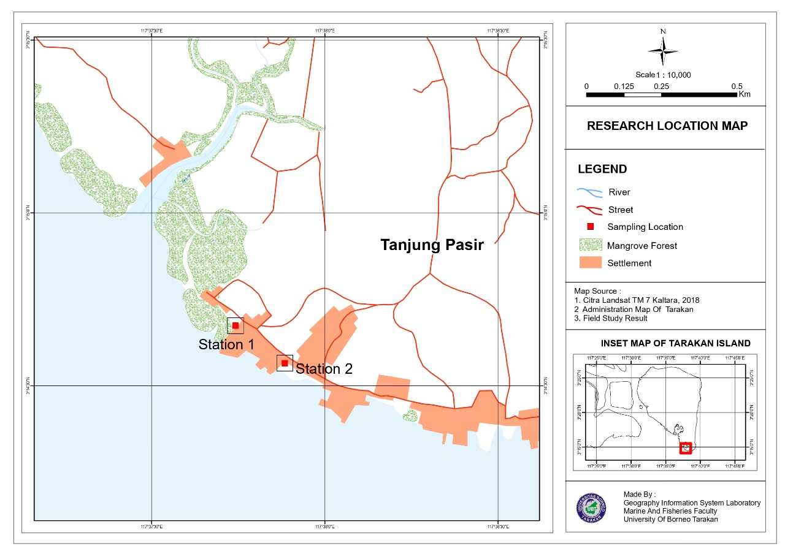

Figure 1. The location of Tanjung Pasir, Tarakan, North Kalimantan.
  - Methods
This study uses a quantitative descriptive method, while the method used in collecting data is directly in the field and followed by calculations [4]. Data collection includes primary and supporting data, and the main information is the biological parameters of the waters, namely plankton, as the research object. In comparison, the supporting data is in the form of environmental factors consisting of physical parameters (temperature, brightness, and salinity) and chemical parameters (pH, nitrate, and phosphate).
  - Data Analysis
The fish survival rate was calculated from the initial number of fish and mortality after the experiment was completed. The absolute growth of fish were determined from the mean of initial and final weight and length of fish, respectively for absolute weight growth and length growth. Meanwhile, feed efficiency was calculated by the formula of NRC An abundance of phytoplankton using RSC (Sedgewick Rafter-counting Cell). The observation using SRC under a microscope magnification of 10x10. The formula for calculating using SRC is as follows (APHA, 2005). Diversity Index (H´) follows (Shannon-Weiner, 1949). The uniformity index was calculated using the Odum formula (1993). This dominance index determines the extent to which biota groups dominate other groups. Large enough dominance will lead to unstable or depressed communities, as per the formula for the dominance index proposed by [5].

Results and Discussion
The types of phytoplankton obtained during sampling in the sea waters of Tanjung Pasir, Tarakan, North Kalimantan in this study were 48 phytoplankton species. The species found consisted of 5 classes, Bacillariophyceae, Coscinodiscophyceae, Cyanophyceae, Dinophyceae, and Mediophyceae. During observations in the sea waters of Tanjung Pasir, Tarakan, North Kalimantan it was found that two classes of phytoplankton were found in the two sampling stations consisting of classes Bacillariophyceae and Dinophyceae. During sampling at Station 1 of the mangrove area of ​​Tanjung Pasir, Tarakan, North Kalimantan 25 species of phytoplankton were found from the Bacillariophyceae class, one species of Coscinodiscophyceae, two species of Cyanophyceae, eight species of Dinophyceae, and three species of Mediophyceae. During sampling at Station 2, The most common types of phytoplankton found were Bacillariophyceae and Dinophyceae. The abundance of Bacillariophyceae and Dinophyceae species because these species can adapt to changes in the aquatic environment so that species dominate over other classes. Tanjung Pasir waters have water quality that can support the life of the biota in these waters, one of which is plankton.
In addition, Station I is a tidal area and part of the estuarine waters that are inundated at low tide and where there is a supply of nutrients from the mainland and mangrove areas so that the availability of nutrients for phytoplankton during the photosynthesis process is fulfilled [6]. During sampling at Station I, the most common types of phytoplankton found were Bacillariophyceae and Dinophyceae. The abundance of Bacillariophyceae and Dinophyceae species because these species can adapt to changes in the aquatic environment so that species dominate over other classes.
According to [7], phytoplankton of the Bacillariophyceae class has a role as a determinant of fertility and also as a bioindicator of pollution and has cosmopolitan properties so that it can live and breed in various polluted water conditions. At the time of sampling at station II in the sea waters of Tanjung Pasir, Tarakan city, where there are community activities that have the potential to produce domestic waste (household waste), it was found that there were 25 species of phytoplankton from the Bacillariophyceae class, two species of Coscinodiscophyceae, two species of Cyanophyceae, five species of Dinophyceae, and Mediophyceae 3 species. The quality of the waters in station II can still support the life of the Bacillariophyceae and Dinophyceae types.
Bacillariophyceae (diatoms) are the leading group of microalgae that are most commonly found in all marine waters, both coastal and oceanic waters [8]. Bacillariophyceae (diatoms) has an essential role as a bioindicator of water quality and has advantages over other organisms. Diatoms have a wide distribution, very varied population, have an essential role in the food chain, short life cycle, and fast reproduction, almost all of which are on the surface of the substrate. Many species of diatoms are sensitive to environmental changes to identify changes in water quality in the short and long term [9]. Phytoplankton class Bacillariophyceae (diatoms) and class Dinophyceae are one type of phytoplankton that dominates all types of phytoplankton throughout the world [10]. Diatoms generally have a size ranging from 5 m–2 mm, with the particular main characteristic of having a silicate-containing cell wall. When Bacillariophyceae dies, their shells will remain intact and settle into the sediment. According to [11], the Bacillariophyceae class can grow faster than other types of phytoplankton because the Bacillariophyceae class can live even in low light conditions, and can regenerate and reproduce in more significant numbers than other phytoplankton types. In general, Bacillariophyceae are single, solitary cells. However, some live connected and form a colony like a chain. Class Bacillariophyceae has cells with shapes that vary from species to species and vary in size within one species [12].
Dinophyceae class or Dinoflagellate type phytoplankton can be found in all waters. According to Fokuyo and Taylor (1989) in Sediadi (1999), Dinoflagellates are flagellated group organisms, both photosynthetic and non-photosynthetic. Dinoflagellate phytoplankton is single-celled phytoplankton that is toxic or toxic when abundant in waters that cause the Red-tide phenomenon, a natural phenomenon thought to cause discoloration of seawater (discoloration) and can cause the death of organisms in the waters. Dinoflagellates generally range from 5-200 m (Kennish, 1990). The characteristics of this class of Dinoflagellates are single celled, do not have an outer shell, and are light brown.

Types of Zooplankton
In this study, the types of zooplankton obtained during sampling in the seawaters of Tanjung Pasir, Tarakan city, were four types of zooplankton classes. The species found included classes Crustacea, Ciliata, Protozoa, and Mollusca. During observations in the waters of Tanjung Pasir, Tarakan city, one type of zooplankton was found in both sampling stations, namely zooplankton from the Crustacea class. Class Crustacea was the most abundant in both study sites. Crustaceans are planktonic larvae that, when significant, will become crustaceans. According to [13], the crustacean class is a significant zooplankton group as it is the primary production chain with large or small carnivores. The Crustacea class dominates in all marine waters. According to [14], Crustaceans are zooplankton that has an essential role in the waters, one of which is food for fish in the waters. The number of species that are often found shows that crustaceans are zooplankton with wide adaptability and tolerance to water quality and environmental changes [14].

Plankton Abundance
Abundance of phytoplankton station I and station II
Figure 1. Phytoplankton abundance
There are differences in phytoplankton abundance at Station 1 and Station 2 because the two sampling sites have different aquatic environments. The abundance of phytoplankton in the Tanjung Pasir area of ​​Tarakan City at Station 1 was 354 cells/l, while the abundance of phytoplankton at station 2 was 202 cells/l. The abundance of phytoplankton at station 1 in the mangrove area and station 2 near residential areas is included in low abundance, and this refers to Soegianto's (1994) statement in [15] that abundance with a value of <1,000 ind/l is low, abundance between 1,000-40,000 ind/l is moderate, and abundance >40,000 ind/l is high. The low abundance of phytoplankton in water is influenced by several factors, including temperature, salinity, pH, levels of nitrate and phosphate nutrients, and especially the intensity of light entering the waters. According to the opinion [16], the physical and chemical factors of the waters are factors that affect the growth of phytoplankton, such as light intensity, dissolved oxygen, temperature, and the presence of nutrients in the form of nitrogen and phosphorus, while in the biological aspect it is in the form of predation activity by animals, death and death, decomposition.
The abundance values ​​were obtained at the time of sampling at station I in the mangrove area because the nitrate and phosphate content was high and would be utilized by phytoplankton for growth. The occurrence of tides greatly affected the abundance and distribution of plankton. It can also be influenced by water conditions where sampling in the morning, the water conditions are clear, so it can be suspected that phytoplankton is photosynthesizing and multiplying, causing the abundance of phytoplankton to be high. In contrast, the abundance of plankton decreases due to bad weather, resulting in oxygen content and lack of oxygen. The intensity of light entering the waters can affect the photosynthetic process of phytoplankton. Nutrients (nitrate and phosphate) are essential for phytoplankton's growth and metabolism of phytoplankton, so nitrate and phosphate nutrients affect the abundance of phytoplankton. Phytoplankton is an indicator to evaluate the quality and level of water fertility (Ferianita Fachrul et al., 2005). However, suppose the concentration of these two substances is enormous in the waters and exceeds the threshold value. Eutrophication (nutrient enrichment) is characterized by phytoplankton blooms, causing the death of various types of marine biota. The fertility of the waters as the primary source of nutrients in the mangrove area comes from the feeling of falling mangroves.
The lack of abundance of phytoplankton obtained during sampling at station II, which is close to residential areas, can be caused by community activities that have the potential to produce domestic waste in the area which will have an impact on the aquatic environment where plankton sampling is located. According to the opinion [17], the existence of activities carried out by humans can cause changes in water physicochemical factors. It affects the abundance and growth of phytoplankton.
Class Bacillariophyceae (Diatom) and class Dinophyceae are the classes that are commonly found in the research location. The same results of research from [18]; Adiba (2008), and Arinardi et al. (1997) stated that phytoplankton from the Bacillariophyceae and Dinophyceae classes were found to be abundant because phytoplankton from these two classes is the principal members of phytoplankton found in all parts of marine waters, both coastal and oceanic waters. According to [19], the class Bacillariophyceae is the most abundant phytoplankton found in various aquatic habitats, especially in waters with cold temperatures. Because of this ability, the class Bacillariophyceae can be used as a biological indicator of unpolluted waters. Meanwhile, according to Cokrowali et al. (2014).

Abundance of zooplankton station I and station II
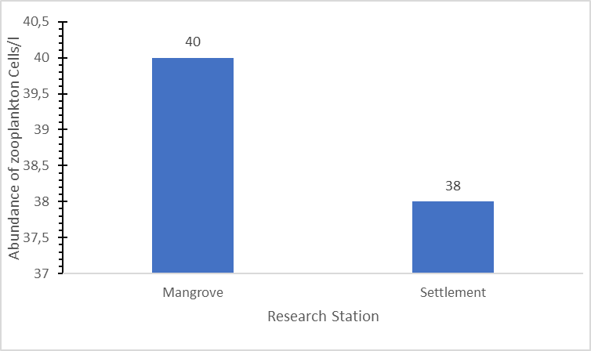
Figure 2. Zooplankton abundance
The abundance of zooplankton in the sea waters of Tanjung Pasir, Tarakan city, Station 1 was 40 ind/L, while the abundance of zooplankton at station II was 38 ind/L. The lack of abundance of phytoplankton influences the low abundance of zooplankton because zooplankton tends to follow the growth of phytoplankton which is the primary food source for zooplankton. Zooplankton preys on phytoplankton so that the phytoplankton population decreases. The production of zooplankton is slower than the production of phytoplankton. So that the peak of zooplankton production always occurs after the peak of phytoplankton production, and in general, a greater abundance of phytoplankton will be found than the abundance of zooplankton [20]. As stated by [21] that the amount of each type of plankton can be different depending on the availability of food.

Plankton Diversity Index (H')
Diversity index (H') of phytoplankton station I and station II
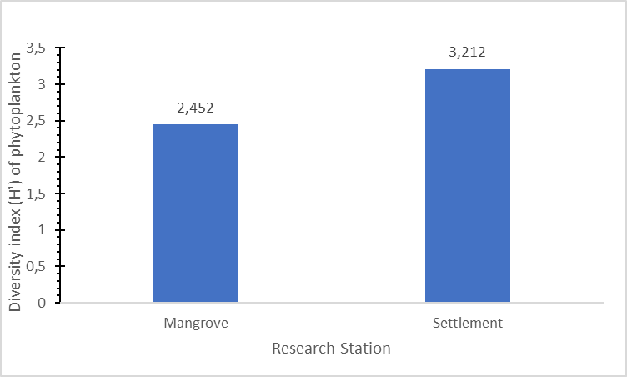
Figure 3. Phytoplankton diversity index

The Phytoplankton diversity index in Tanjung Pasir at the observation at station I of the mangrove area is 2.452, while the diversity index at station II, closes to residential areas, is 3.212. [22] If the value of H'<1 is obtained, the aquatic biota community is declared unstable (low). If the value of 1<H'<3, then species diversity and community stability are moderate. If the value of H'>three, then the species diversity is declared very stable (high). [23] said that the more individuals or species, the greater the number of plankton diversity in the waters, and vice versa. If no individuals or species dominate or the number is more significant, the value of plankton diversity in the waters is moderate to high. With high, the value of phytoplankton diversity at station I and station II was moderate to high. According to Sari et al. (2017), the adaptability of plankton to the environment and the availability of organic matter (nitrate and phosphate) influences the index of plankton diversity in waters. The diversity of plankton species in an aquatic ecosystem is often used as a benchmark to determine the primary productivity of the waters and the condition of the aquatic ecosystem. These two things have a mutually influencing relationship Sianturi (2021).
Diversity index (H') of zooplankton station I and station II
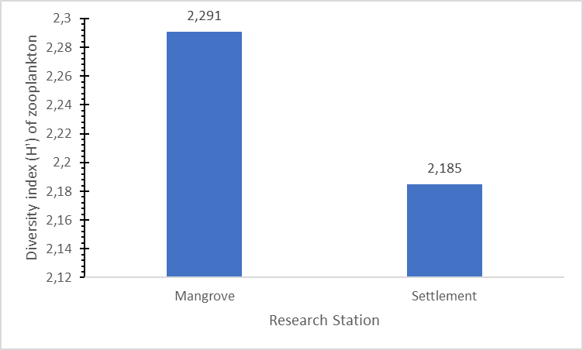
Figure 4. Zooplankton diversity index
The index of zooplankton diversity in the sea waters of Tanjung Pasir, Tarakan city, at the time of observation at station I of the mangrove area was 2.291, while the index of zooplankton diversity at station II close to residential areas was 2.185 at station I and station II, the value of diversity was moderate. According to [3], species diversity is said to be low if the distribution is uneven and there are individuals or species found in abundance. On the contrary, if high diversity is suspected because of the ability of several generals to utilize and tolerate aquatic environmental factors, while biota that has diversity is said to be low is thought to be due to the inability to compete in foraging.

Uniformity Index (E) Plankton
Uniformity Index (E) of phytoplankton station I and station II
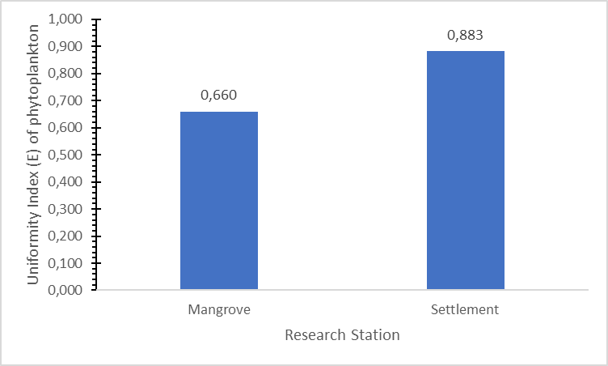
Figure 5. Phytoplankton uniformity index
The phytoplankton uniformity index found in the sea waters of Tanjung Pasir, Tarakan City, at station I in the mangrove area got a value of 0.660, and the phytoplankton uniformity index at station II close to residential areas got a value of 0.883. The uniformity value at station I and station II is classified in the category of high uniformity or evenly distributed. The high uniformity index at each plankton sampling location is due to the absence of individuals or species that dominate the waters or their distribution is evenly distributed. In contrast, a low uniformity value indicates that individuals or species dominate the waters, so the distribution of the number of each species is not the same. If the diversity value is low, the uniformity value is also low (Pirzan et al.)
The uniformity index (E) of zooplankton at station I and station II
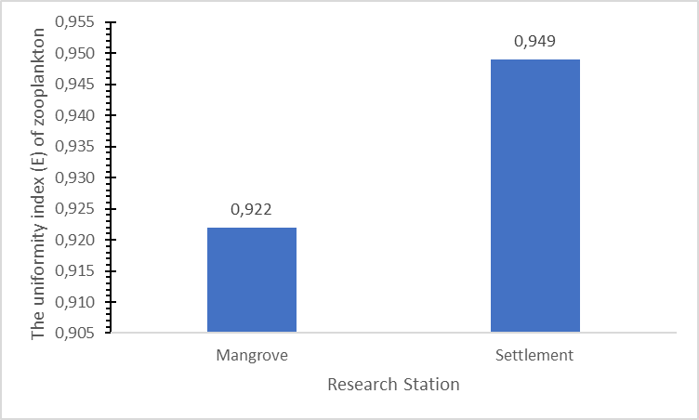
Figure 6. The uniformity index (E) of zooplankton
The zooplankton uniformity index found in Tanjung Pasir, Tarakan City's sea waters at station I in the mangrove area, got a value of 0.922. In contrast, the uniformity index value at station II near residential areas was 0.949. The high uniformity index at each plankton sampling location is due to the absence of individuals or species that dominate the waters or their distribution is evenly distributed. In contrast, a low uniformity value indicates that some individuals or species dominate the waters, so the distribution of the number of species is not the same. If the diversity value is low, the uniformity value is also low.

Plankton Dominance Index (C)
Dominance Index (C) of phytoplankton station I and station II
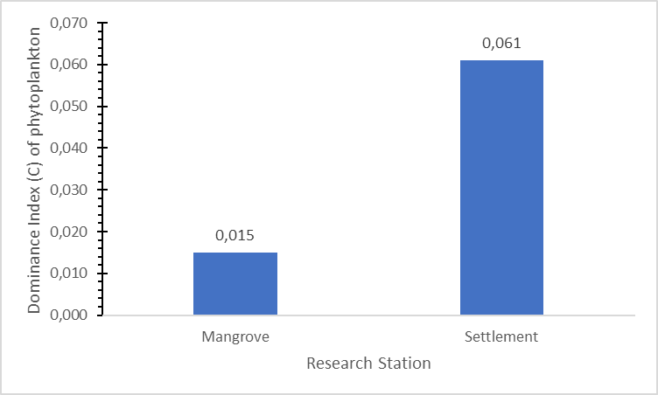
The value of the phytoplankton dominance index found in the sea waters of Tanjung Pasir, Tarakan City, at station I in the mangrove area, got a value of 0.015 and the dominance index found at station II near residential areas was 0.061. [3] says that if the dominance index is close to 0, no particular individual or species dominates. On the other hand, if the dominance index value is close to 1 or equal to 1, no specific individuals or species dominate in the waters. At station I, the mangrove area and station II, near residential areas, there was no dominant species in the two sampling locations during the observations at both locations.
Dominance Index (C) Zooplankton station I and station II
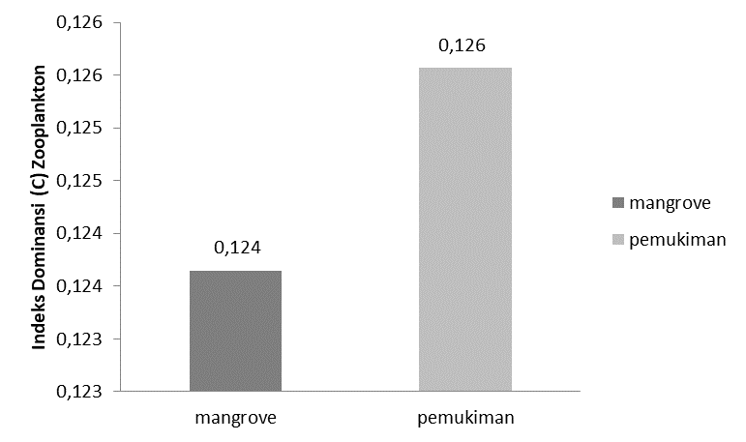
Figure 8. Dominance index (C) of zooplankton.

The value of the zooplankton dominance index in the seawaters of Tanjung Pasir, Tarakan city, at station I in the mangrove area, got a value ranging from 0.124, and the dominance index found at station II near residential areas got a value ranging from 0.126. [3] says that no particular individual or species dominates if the dominance index is close to 0. On the other hand, if the dominance index value is close to 1 or equal to 1, then some individuals or species dominate in the waters.

Water Quality Parameters
From the results of the measurement of water quality parameters obtained, the temperature at Station 1 ranged from 26-30️C while the temperature at station II ranged from 25-30️C. The average water temperature at station I in the mangrove area is 28️ C. The average water temperature at station II close to residential areas, is 27️C. Water temperature is one of the factors that affect the life of organisms in it, including phytoplankton, an increase in temperature can affect the metabolic rate and photosynthesis process of phytoplankton. At the two sampling locations, the water temperature is an ideal temperature for the development of phytoplankton. The temperature range at station I and station II have a good range for the growth and survival of plankton. [24] said the temperature that organisms can tolerate in the waters ranges from 20-30️C, and the optimal temperature for the growth of phytoplankton in the waters ranges from 25-30️C, while the optimal temperature for zooplankton growth ranges from 15-35️ C.
Brightness plays a significant role in determining the growth of phytoplankton, the statement of [25]. The brightness of the waters will be closely related to the photosynthetic process of phytoplankton in these waters. The brightness at station I in the mangrove area ranges from 44.5 to 81.45 cm, while the brightness at station II near residential areas ranges from 41.5 to 73 cm. The average brightness value at station I is 59.09 cm, and the average brightness value at station II near residential areas is 55.4 cm. Brightness can be affected by high and low tides and the intensity of sunlight entering the waters. The brightness of water is very much needed by phytoplankton in photosynthesis. Photosynthesis is essential for phytoplankton to absorb energy and then use it to produce food. [26] say that the high and low brightness of the waters is strongly influenced by the intensity of sunlight that penetrates the water layer. The brightness of the waters, the better, especially for phytoplankton in their activities, so the food supply for zooplankton is fulfilled. The range of brightness values ​​at station I in the mangrove area and station II near residential areas is good for plankton growth. Opinion [27] says that a good brightness value for the survival of aquatic organisms is >45 cm. Soeseno (1984) said that what determines the size of the brightness value in water is suspended objects, micro-organisms, and the color of the waters themselves.
Salinity at station I in the mangrove area ranges from 26-30 ppt, while salinity at station II near residential areas ranges from 27-30 ppt. The average salinity value at station I in the mangrove area is 28.4 ppt, and the average salinity value at station II near residential areas is 28.6 ppt. Salinity is the level of dissolved salt in water. The salinity distribution is influenced by several factors, such as water circulation patterns, evaporation, rainfall, and river

flow [12]. The salinity values ​​at Station I and Station II were very good for plankton growth. According to opinion [28], marine plankton can live in a salinity range more significant than 20 ppt. [29] said salinity > 20 ppt or even in marine waters with salinity up to 32 ppt because fish have been carried out through the use of euryhaline characters.
The pH value at station I in the mangrove area ranged from 7.42-7.98, while the pH at station II near residential areas ranged from 7.09-7.86. The average pH value at station I is 7.65, and at Station, II is 7.37. The optimum water pH value for phytoplankton growth in a body of water ranges from 7-8.5, which is classified as alkaline [30]. According to [31], pH affects the level of biochemical processes in water. The pH value can change due to factors that affect changes in pH in waters, such as photosynthetic activity, temperature and pollution and instability of the aquatic environment. The pH value at station I in the mangrove area and station II near residential areas has an optimal pH for plankton growth.
Nitrate levels obtained the Station I in the mangrove area ranged from 0.058-0.305 mg/l, while nitrate at station II ranged from 0.045-0.037 mg/l. This nitrate is higher than nitrate for the needs of aquatic biota, one of which is plankton. According to the MENLH Decree No. 51 of 2004, the quality standard of seawater concentration suitable for marine life is 0.008 mg N-NO3/L [32]. According to (Chu et al. 1982) that the range of nitrate levels of 0.3-0.9 mg/l is sufficient for the growth of organisms in the waters >3.5 mg/l can harm the waters. Meanwhile, according to [4], nitrogen levels that are more than 0.2 mg/l can increase nitrate nitrogen in waters, thus causing nutrient enrichment (eutrophication). [35] State that nitrate is one of the essential nutrients in the water that helps in the growth process of living organisms. But if the concentration of nitrate is excessive, it will stimulate the growth of algae so that the waters will lack oxygen and oxygen. Cause death of aquatic organisms. The nitrate level at station I is high because the sampling is in the mangrove area, where it feels like the fallen mangrove leaves by decomposers to produce organic matter that will assist in forming nitrate compounds. There are also community activities near the sampling site. And lead to higher nitrate levels. Nitrate levels at station II are high because they are near residential areas, and the presence of nitrate sources from land to waters originates from community activities, one of which is domestic waste containing nitrate, which can cause high nitrate levels in these waters. [33] said that various factors present low and high nitrate content, including the current carrying nitrate and the abundance of phytoplankton.
Phosphate is a chemical parameter of water that describes water fertility, and phosphate uses the growth of plankton and other aquatic organisms. Phosphate does not exist in the free state, but phosphate-dissolved inorganic compounds are orthophosphates and polyphosphates) and organic compounds in the form of particulates. Phosphate levels obtained the Station I in mangrove areas ranged from 0.017-0.051 mg/l, while station II near residential areas ranged from 0.004-0.078 mg/l. Phosphate levels at station I in the mangrove area and station II near residential areas are classified as low fertility to medium fertility. According to [4], the fertility of the waters into three levels include waters with low fertility have a total phosphate concentration of 0-0.02 mg/l, and medium fertility waters have a total phosphate concentration ranging from 0.021-0.05 mg/l.
According to the research results of [34], The relationship between phosphate and the abundance of phytoplankton shows (r) has a moderate correlation. In comparison, waters with high fertility have total phosphate concentrations ranging from 0.51-0.1 mg/l. Phosphate concentration in the range of 0.27 mg/l is required and will be a limiting factor if it is less than 0.02 mg/L [35]. To achieve optimal plankton growth, an If the phosphate level is deficient in water with a value of (<0.01 mg/l), the growth of plants and algae will be blocked. This condition is called oligotrophic. Meanwhile, if the phosphate level is high, the growth of plants and algae is no longer limited. This situation is called autotrophs [35].

Conclusion

The plankton community structure in the Tanjung Pasir seawater, Tarakan city, North Kalimantan with an abundance of plankton at station I and station II, is included in the category of low water fertility. The plankton diversity index at Station I and Station II is included in the moderate to high diversity index with a high plankton uniformity index. The plankton dominance index is classified as low dominance or no species, the number is dominant at station I and station II, or the number of distributions is clustered. Chemical and physical factors in Tanjung Pasir waters at station I and station II are still suitable for the life of aquatic organisms. The most common types of phytoplankton found at Station I and Station II were class Bacillariophyceae, Dinophyceae, and zooplankton from class Crustacea.

This study has successfully documented the baseline data for A. formosa growth and its application in coral nurseries. A. formosa has excellent proto-branch regeneration and fast growth rates, thus can be suggested as a reef health indicator around Malaysia. The coral nursery work reported in this study was the first in Malaysia, which was managed by Reef Check Malaysia. With the current trend of increasing pressures on reef ecosystems, coral transplant is indeed an excellent method for active reef conservation and restoration. Nevertheless, continuous long term, systematic monitoring are needed in order to have greater understanding of the A. formosa growth and dynamics in the tropical coral reef ecosystems.

Acknowledgement

We are grateful University of Borneo Tarakan (UBT) for the opportunity to obtain funding for research. Also, we thank the Faculty of Fisheries Marine University of Borneo Tarakan and Management of Water Resources. We thank the research members for their cooperation in completing the research.

References

[1] BPS. 2016. Provinsi Kalimantan Utara dalam Angka (Kalimantan Utara Province in Figures). BPS Kalimantan Timur. 255 hlm.
[2] Hartoko, A. 2013. Oceanographic Characters and Plankton Resources Of Indonesia. Graha Ilmu. Yogyakarta.
[3] Odum, E. P. 1993. Dasar-Dasar Ekologi. Edisis ketiga. Terjemahan: Samingan, T., Srigandono. Fundamentals Of Ecology. Third Edition. Gadjah mada Universit Press.
[4] Effendi, H. 2003. Telaah Kualitas Air bagi Pengelolaan Sumber Daya dan Lingkungan Perairan. Kanisius: Yogyakarta: 258 hlm.
[5] Rahmatullah, M., Sarong, A., dan Karina, S. 2016. Keanekaragaman dan Dominansi Plankton di Estuari Kuala Rigaih Kecamatan Setia Bakti Kabupaten Aceh Jaya. Jurnal Ilmiah Kelautan dan Perikanan Unsyiah, 1 (3): 325-330.
[6] Lathifah, N., Hidayat, W. J., Muhammad, F. 2017. Struktur Komunitas Fitoplankton Sebagai Dasar Pengelolaan Kualitas Perairan Pantai Mangrove di Tapak Tugurejo Semarang. Vol. 19 (2): Hal. 164-169
[7] Sachlan, M. 1982. Planktonologi. UNDIP: Semarang
[8] Arinardi, O. H, Trimaningsih dan Sudirdjo. 1994. Pengantar Tentang Plankton serta Kisaran Kelimpahan dan Plankton Predominan di Sekitar Pulau Jawa dan Bali. Puslitbang Oseanologi-LIPI. Jakarta.108 hal.
[9] Gell, P. A., A. J. Sincock, J. A. Sonneman, M. A. Illman and M. A. Reid. 1999. An Illustrated Key to Common Diatom Genera from Southern Australia. University of Adelaide, Adelaide, New South Wales: 63 p.
[10] Nybakken, J.W. 1992. Biologi Laut: Suatu Pendekatan Ekologis. Terjemahan oleh H. Muhammad Eidman. PT Gramedia. Jakarta. 480 hlm.
[11] Usman, M.S., Kusen, J.D., & Rimper, J.R.T.S.L. (2013). Struktur Komunitas Plankton di Perairan Pulau Bangka Kabupaten Minahasa Utara. Jurnal Pesisir dan Laut Tropis, 1(2): 51-57
[12] Nontji. A. 2008. Plankton Laut. LIPI Press, anggotaIkapi: Menteng, Jakarta
[13] Purnamasari, A. 2016. Struktur Komunitas Plankton di Perairan Mangrove Karangsong, Kabupaten Indramayu, Jawa Barat. Jurnal Biologi. 5 (5): Hal 39-51
[14] Paramudhita, W. Endrawati, H. Nuraini, R. A. 2018. Struktur Komunitas Zooplankton di Perairan Desa Mangunharjo Kecamatan Tugu Semarang. Buletin Oseonografi Marina. Vol 3 (2) 113-120
[15] Madinawati. 2010. Kelimpahan Dan Keanekaragaman Plankton Di Perairan Laguna Desa Tolongano Kecamatan Banawa Selatan Jurnal, 111 (2): 119123.
[16] Goldman, C. R and A. S. Horne. 1983. Study State Growth of Phytoplankton in Continous Culture: Comparison of Internal and External Nutrient Equation. 251 – 351 hal.
[17] Giyanto. Winardi, E. Kusmanto. Salmin. Soeroyo, A. Manuputty, S. R. Suharti, R. dan Sutryadi. (2004). Study Baseline Ekologi Batam. Jakarta. CRITCCOREMAP. 118 p. (tidak diterbitkan)
[18] Damar, A. 2003. Effects of Enrichment on Nutrient Dynamics, Phytoplankton Dynamics and Productivity in IndonesianTropical Water: A Comparison Between Jakarta Bay, Lampung Bay and Semangka Bay, Ph.D Dissertation Christian Albrechts University. Kiel.Germany.
[19] Putra, A.W, Zahidah W.lili. 2012. Struktur Komunitas Plankton di Sungai Citarum Hulu Jawa Barat Perikanan dan Kelautan. ISSN 2088-3137. Vol.3
[20] Basmi, J. 1988. Perkembangan Komunitas Fitoplankton Sebagai Indikasi Perubahan Tingkat Kesuburan Kualitas Perairan. Bogor: Jurusan Ilmu Perairan Fakultas Pasca Sarjana. Institut Pertanian Bogor.
[21] Hendrick, P. W. (1984). Population Biology: The Evolution and Ecology of Population. Jones and Bartlet Publ. Inc. USA. 45pp.
[22] Siregar, L.L., Hutabarat, S., Muskananfola, M.X. (2014). Distribusi Fitoplakton Berdasarkan Waktu Dan Kedalaman Yang Berbeda Di Perairan Pulau Menjangan Kecil Karimunjawa. Diponegoro Journal Of Maquares. 3(4):9-14
[23] Khalik, A., Syam, H., Kaseng, S.E. (2021). Keanekaragaman Plakton Pada Tambak Budidaya Padi Dan Udang Windu Sistem Mina Padi Air Payau Di Kabupaten Maros. Program Studi Pendidikan Teknologi Pertanian Fakultas Teknik, Universitas Negeri Makassar.
[24] Azwar, E. 2001. Pengaruh Aktivitas Pabrik Semen Andalas Terhadap Kelimpahan Deversitas dan Produktivitas Plankton di Perairan Pantai Lhoknga Kabupaten. Fakultas MIPA UNSYAH. [e-jurnal]
[25] Arofah, S., Sari. L A., Kursdawati, R. 2021. Kecerahan suatu perairan akan berkaitan erat dengan proses fotosintesis fitoplankton di perairan tersebut. IOP Conf. Series: Earth and Environmental Science 718 (2021) 012018
[26] Hutabarat, S., dan Evans S. M., 2014. Pengantar Oseanografi. Penerbit Universitas Indonesia (UI-Press). Jakarta. 159 hlm
[27] Asmawi S (1985) Ekologi Ikan. Departemen Pendidikan dan Kebudayaan. Fakultas Perikanan Universitas Lambung Mangkurat. Banjarbaru.
[28] Sachlan, H.S (1982). Planktonologi. Fakultas Perikanan dan Peternakan Universitas Diponegoro. Semarang.
[29] Aziz, R., Barades, E.2021. Adaptasi Benih Ikan Nila (Oreochromis niloticus) Pada Kenaikan Salinitas Berbeda. Jurnal Perikanan (2021) Volume 11. No. 2 : 251-258
[30] Dimenta, R.A., Agustina,R., Machrizal, R., Khairul. 2020. Kualitas Sungai Bilah Berdasarkan Biodiversitas FitoplanktonKabupaten Labuhanbatu, Sumatera Utara. Jurnal Ilmu Alam dan Lingkungan 11(2), (2020).24-33.
[31] Sudinno, D., Jubaedah, I., Anas., P. (2015). Kualitas Air dan Komunitas Plankton Pada Tambak Pesisir Kabupaten Subang Jawa Barat. Sekolah Tinggi Perikanan, Jurusan Penyuluhan Perikanan. Jurnal Penyuluhan Perikanan dan Kelautan. 9(1): 13-28
[32] Zulhasni., Dwi, P.D., Dasminto., dan Rusli, A. (2005). Peraturan Pengendalian Kerusakan Pesisir Laut. KLH Jakarta
[33] Patty, S, I. 2015. Karakteristik Fosfat, Nitrat, dan Oksigen Terlarut di Perairan Selat Lembeh, Sulawesi Utara. Jurnal Pesisir dan Laut Tropis, 2 (1): 1-7
[34] Wijaya.N.I., Sari,A.K.A., Maimah.2022. Pengaruh Konsentrasi Fosfat dan Nitrat terhadap Kelimpahan Fitoplankton di Perairan Mangrove Gunung Anyar, Surabaya. Jurnal Pertanian Terpadu 10(1): 64-77
[35] Siregar, M.H. (2009). Studi Keanekaragaman Plankton di Hulu Sungai Asahan Porsea. Skripsi. Departemen Biologi Fakultas Matematika dan Ilmu Pengetahuan Alam Universitas Sumatra Utara Medan.

