Cholinetrase concentration in the blood of three types of cattle raised on land exposed to Organophosphates

Ali Harokan¹, Totong Kamaluddin², Daniel Saputra², Nurhayati Damiri^{2,3*}
¹Student of Doctoral Program of Enviromental Science, Graduate school, Universitas Sriwijaya
²Doctoral Program of Enviromental Science, Graduate School, Universitas Sriwijaya
³Pest and Plant Diseases Department, Faculty of agriculture, Universitas Sriwijaya
*Corresponding author email:nurhayati@fp.unsri.ac.id

Abstract. Organophosphate pesticides are one of the causes of contamination in animal feed. The cholinesterase enzyme test is used to diagnose toxic exposure due to organophosphate pesticides. Quantitative research with survey design using cross sectional design using 35 samples of cows. The study was conducted in March - September 2020. Concentration measurement on cholinesterase enzyme concentrations of blood plasma used the biosystem A15 DGKC-Colorimetric Kinetic method. This study aims to evaluate the concentration of the enzyme cholinesterase as a marker of organophosphate poisoning in cattle. Blood samples were collected from the ventrolateral neck veins of male and female cattle aged 1-7 years and collected from local cattle in the Ogan Ilir area. The results showed that the cows raised in breeders were exposed to organophosphate pesticides as indicated by a decrease in the concentration and levels of the cholinesterase enzyme in the plasma of female cows. Cholinestrase enzyme levels in female cows were 0.20 ± 0.067 U / ml and bulls were 0.27 ± 0.183 U / ml. The highest concentration of cholinesterase enzyme levels occurred in cows aged 2 years, namely 0.25 ± 0.34 U / ml and the lowest was in cows aged 7 years, namely 0.12 ± 0.04 U / ml.
Key words: Cows, Cholinesterase, Environment
Abstract. Pestisida organofosfat merupakan salah satu penyebab kontaminasi pada pakan ternak. Pemeriksaan enzim cholinesterase digunakan untuk mendiagnosis pemaparan keracunan akibat pestisida organofosfat. Penelitian kuantitatif dengan desain survei menggunakan desain cross sectional dengan menggunakan 35 sampel sapi. Penelitian dilakukan pada bulan Maret - September 2020. Pengukuran Kadar konsetrasi enzim cholinesterase plasma darah menggunakan alat biosystem A15 metode DGKC-Colorimetric Kinetic. Penelitian ini bertujuan untuk mengevaluasi kadar konsentrasi enzim kolinesterase sebagai penanda keracunan organofosfat pada sapi. Sampel darah diambil dari vena ventrolateral leher sapi jantan dan betina berumur 1-7 tahun dikumpulkan dari sapi lokal di wilayah Ogan Ilir. Hasil penelitian menunjukkan bahwa sapi yang dibudidayakan di peternak terpapar pestisida organofosfat yang ditunjukkan dengan penurunan konsentrasi dan kadar enzim kolinesterase dalam plasma sapi betina. Kadar enzim kolinestrase pada sapi betina 0,20 ± 0,067 U / ml dan sapi jantan 0,27± 0,183 U / ml . Konsentrasi Kadar enzim kolinesterase tertinggi terjadi pada sapi umur 2 tahun yaitu 0,25 ± 0,34 U / ml dan terendah pada sapi umur 7 tahun yaitu 0,12 ± 0,04 U / ml.
Key words: Sapi,Cholinesterase,Lingkungan

- Introduction

Pesticides are strong acid esters or phenols which can cause skin irritation, redness and dermatitis on the skin. Its use can cause nervous system disorders. This can occur in the peripheral nerves and central nervous system [1].
Pesticides have lipophilic properties which can be stored in the fatty tissue of the animal's body. Pesticide residues present in feed and eaten by livestock will transfer to meat through the food supply chain as a result, animal products such as meat can contain pesticide residues that endanger public health [2].
Pesticides are metabolized in the liver slowly before being released into the circulatory system and finally stored in fat [3]. Contaminated animal feed is the main source of pesticide entry into the animal's body. Animal body systems will be contaminated with pesticide residues and not only directly affect animals but also affect the health of humans who consume the animal's meat [4].
Organophosphate pesticides inhibit cholinesterase activity by means of nerve impulses by binding to cholinesterase, so that acetylcholine hydrolysis does not occur. Inhibition can last from a few hours to a few weeks depending on the type of anticholinesterase. Aceticolin is a neurotrasminter that is located between nerve endings and muscles to continue nerve stimulation [5].
Acetylcholinesterase activity plays a fundamental role during the inflammatory response regulating acetylcholine levels. This enzyme functions biologically by regulating the neurotransmitter acetylcholine, an anti-inflammatory mediator. Specific choline ester acetylcholinesterase produced by many cells, including lymphocytes, which are found in higher concentrations in the blood and central nervous system [6].

- Materials And Methods
This research took place at breeders in Ogan Ilir Regency. The research was in June-September 2020. The tools and materials used in this study were: Blood tube (3 ml non heparin red color), cooler box, Eppendorf, needdle BD vacu 21 G, holder vacutainer, centrifugation at 10000 rpm ( Centurion, UK)) and biosystem A15. This and biosystem A15. This research was a quantitative study with a survey design using a cross sectional design by using 35 samples of cow blood plasma.
Blood samples were taken in the ventrolateral neck vein of cattle aged 1-7 years. DGKC-Colorimetric Kinetic method using biosystem A15. The principle of Butyrylthiocholine + H2O CHE Thiocholine + Butyric acid. In this study, 3 cows and 32 females. Beef blood was centrifuged at 10000 rpm for 10 minutes to collect blood plasma. Then used the A-15 biosystem tool. Carefully to open the cap of the control serum and add 5 ml of aquabidest. Close the bottle again and mix gently for 30 minutes and avoid forming foam. Put the control serum into the sample cup. Carrying out control with the biosystem A-15.
Parameters observed in the study included cholinesterase levels in cow plasma, differences in mean sex and mean age of cows. The data collected were then analyzed both tabulated and statistical SPSS version 16. Concentrations of cholinesterase enzyme levels with the DGKC-Colorimetric Kinetic method used the biosystem A15.

- Results And Discussion
Characteristics of cattle breeders
The characteristics based on the type of cattle are listed in Table 1: Types of cattle available to breeders

Type of cow | Persentase
PO (breeders are ongole) | 74.3
Brahman | 5.7
Local | 8.6
Brongus | 2.9
Bali | 8.6

Table 1, Shows that the types of cattle available in the breeders are ongole (PO) (74.3%), Brahman (5.7%), local (8.6%), Brongus (2.9%) and Bali. (8.6%).

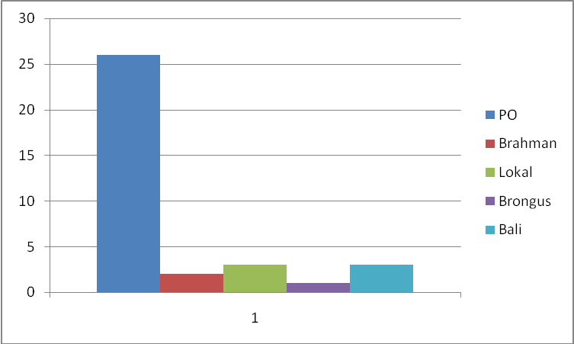
Figure 1. Types of cows on the farm.

The content of cholinesterase in cow blood plasma
Cholinesterase enzyme levels in cows according to sex are presented in Table 1

Table 1.Cholinesterase enzyme levels in blood plasma of male and female cattle

Sex | Mean cholinesterase enzyme levels (U / ml) | Standar Deviation | Standar Error | 95% Confidence Interval for mean |  | Min | Max
 |  |  |  | Lower bound | Upper bound | Min | Max
Male | 0,27 | 0,183 | 0,105 | 0,17 | 0,73 | 0,12 | 0,48
Female | 0,20 | 0,067 | 0,011 | 0,17 | 0,22 | 0,06 | 0,30

Table 1. Showed that the cholinesterase enzyme levels in bulls plasma showed an average value of 0.27 U / ml, which was higher than the cholinesterase enzyme levels in bovine blood plasma of 0.20 U / ml. However, the value of cholinesterase enzyme levels in the plasma of female cows has decreased as indicated by exposure to organophosphate pesticides.

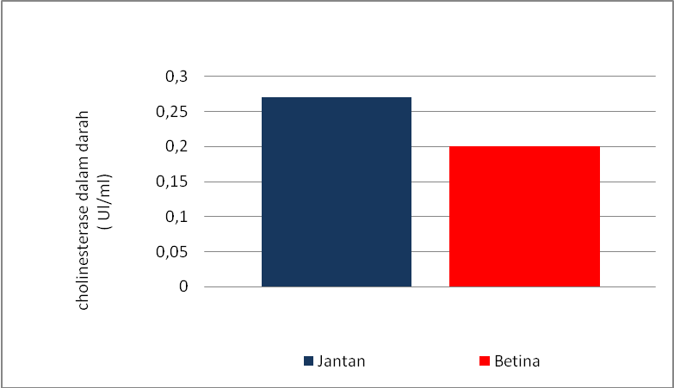

Figure 1. Average levels of the cholinesterase enzyme in the blood of cows according to sex
Cholinesterase enzyme using the Ellman method, the initial mean value of acetylcholinesterase was 624.65 ± 39.32 IU / L. Cholinesterase enzyme in the control group in blood plasma was 0.220 ± 0.083 IU / ml [7]. Cows raised in breeders have been exposed to organophosphate pesticides. This was indicated by the levels of the cholinesterase enzyme in blood plasma. Cholinesterase enzyme levels in cows were 0.20 U / ml

Cholinesterase enzyme levels in bovine blood plasma.
Analysis of the cholinesterase enzyme level test in cows by sex was presented in Table 2

Table 2. Cholinetrase enzyme levels in bovine plasma by age.

Age | Mean cholinesterase enzyme activity (U/ml) | Standar Deviation | Standard Error | 95% Confidence Interval for mean |  | Min | Max
 |  |  |  | Lower bound | Upper bound | Min | Max
2 year | 0,25 | 0,34 | 0,19 | 0,17 | 0,34 | 0,24 | 0,30
3 year | 0,17 | 0,05 | 0,02 | 0,10 | 0,25 | 0,12 | 0,24
4 year | 0,23 | 0,04 | 0,01 | 0,19 | 0,26 | 0,18 | 0,30
5 year | 0,21 | 0,05 | 0,01 | 0,17 | 0,26 | 0,12 | 0,30
6 year | 0,16 | 0,07 | 0,03 | 0,08 | 0,25 | 0,06 | 0,30
7 year | 0,12 | 0,04 | 0,02 | 0,04 | 0,19 | 0,06 | 0,18

Table 2.Cholinesterase levels in blood plasma in cows aged 2 years 0.25 ± 0.34, 3 years old 0.17 ± 0.05, 4 years old 0.23 ± 0.04, 5 years old 0.21 ± 0.05, 6 years old 0.16 ± 0.07 and 7 years. years 0.12 ± 0.04. The highest cholinesterase levels in bovine blood plasma

2 years old and the lowest at 7 years old. However, the value of cholinesterase levels in bovine blood plasma based on age decreased the concentration of cholinesterase levels in cows aged 3 years, 5 years, 6 years and 7 years. The result is an overall reduction in cholinesterase, which indicated the cows were exposed to the organophosphate pesticide

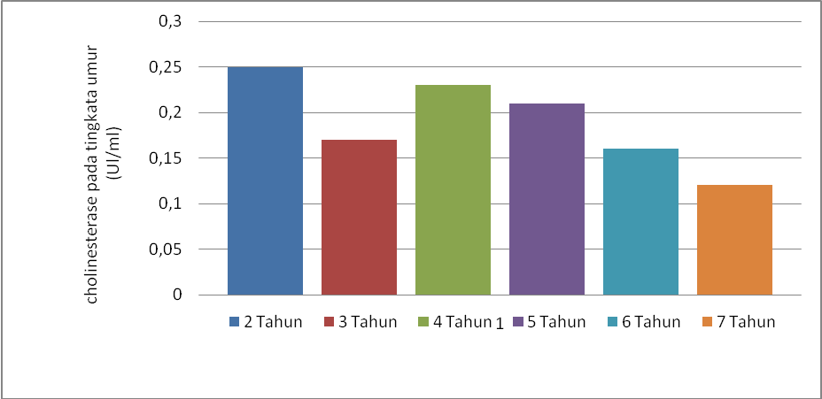
Figure 2. Average levels of the cholinesterase enzyme in the blood of cows at various ages

Cholinesterase enzyme levels in cow blood plasma based on the type of cow

The test analysis of the cholinesterase enzyme levels in cattle based on the type of cow was summarized in Table 3:

Table 3.Cholinesterase enzyme levels in plasma by type of cow.

Type of cow | Cholinesterase enzyme levels mean (U / ml) | Standard Deviation | Standard Error | 95% Confidence Interval for mean |  | Min | Max
 |  |  |  | Lower bound | Upper bound | Min | Max
PO (breeders are ongole) | 0,19 | 0,072 | 0,0142 | 0,164 | 0,223 | 0,06 | 0,30
Local | 0,20 | 0,042 | 0,029 | 0,171 | 0,591 | 0,18 | 0,24
Bali | 0,23 | - | - | - | - | 0,24 | 0,24

Table 3. Shows that the cholinesterase enzyme levels in cow plasma show a mean value of 0.19 U / ml in PO cows, a mean of 0.20 U / ml in local cows and 0.23 Ul / ml in Bali cows. The average cholinesterase levels in the blood of cows by type of cow are listed in Figure 4. Below :

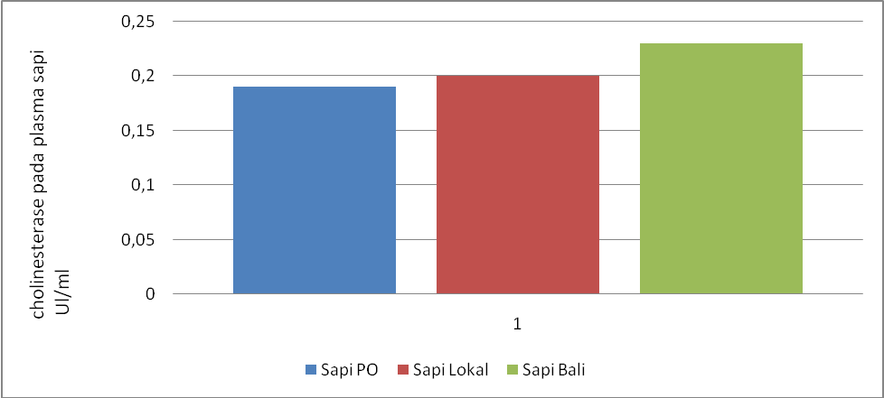

Figure 4. Average levels of the cholinesterase enzyme in the blood of cows from various types of cows

Pearson Correlation Analysis to the levels of the cholinesterase enzyme

The analysis of the Pearson correlation test between age and cholinesterase enzyme levels is summarized in Table 4:
Table 4. Correlation analysis of Pearson age with cholinesterase enzyme levels
 | Cholinesterase Enzyme Level Score
Age score | r = 0,524  p < 0,001  n= 35

Table 4. From the results above, the p value was 0.001 which indicates that the correlation between the age score and the cholinesterase enzyme level score was significant.

The normal cholinesterase enzyme ((µmol / ml / minute) was measured in bovine blood and plasma was obtained in cows aged 3-6 months 0.39 ± 0.11, 1-2 years 0.19 ± 0.03, 2 years old and above. 0.22 ± 0.04 [8]. Acetylcholinesterase in whole blood 5510 ± 600 IU / L in whole blood and 190 ± 30 IU / L in blood plasma for cows aged one to 2 years [9].

Cholinesterases were a group of esterases that hydrolyze choline esters at a higher rate than other esters at the hydrolysis rate than at optimum and controlled conditions. Cholinesterase was primarily responsible for the rapid removal of acetylcolinesterase within one millisecond after release at the cholinergic synapses, thus allowing proper temporal control of muscle contraction [10].

In the in vivo test of cholinsetrase inhibition in sheep, goats and cattle with organophosphate malathion and diazinone insecticides. This insecticide had relatively low toxicity for pets. This pesticide can affect the animal after exposure causing cholinsetrase inhibition at nerve endings and then causing parasympathetic overstimulation [11].
Plasma cholinestrerase activity is often reduced if there was a genetic variant, a number of clinical conditions can reduce its activity, such as liver disease, malnutrition, organophosphate poisoning, burns, renal failure, plasmaferesisi and drugs. Several conditions were associated with increased plasma cholineterase activity, thyroid disease, obesity, nephrotic syndrome and cognitive impairment [12].
Acetylcholinesterase was found in conduction tissues such as nerves and muscles, central and peripheral tissues, motor, sensory fibers, cholinergic and noncholinergic fibers. Acetylcholinesterase activity is higher in motor neurons than in sensory neurons. Acetylcholinesterase is also found in the membranes of red blood cells which were blood group antigens. In mammals the majority of acetylcholinesterase occurs as a tetrameric with a much smaller number of monomers [13]
In addition to organophosphate pesticides, several metals had the potential, such as Hg2 +, Cd2 +, Cu 2+ and Pb 2 + to suppress activity. The potential effect of lead on erythrocyte aceticolinesterase activity during metal exposure was used as a biomarker of lead-induced neurotoxicity in exposed subjects. Polycyclic aromatic hydrocarbons directly inhibit acetylcholinesterase. Polycyclic aromatic hydrocarbons were able to inhibit acetylcholinesterase activity in an addictive manner along with organophosphates to become a noncompetitive acetylcholinesterase inhibito [14].

Discussion

From the research, it can be concluded that cultivated cows were exposed to pesticides by organophosphate pesticides as indicated by a decrease in the levels of the cholinesterase enzyme in the plasma of female cows. cholinesterase enzyme levels in female cows were 0.20 ± 0.067 u / ml. the highest levels of cholinesterase enzymes occurred in cows aged 2 years, namely 0.25 ± 0.34 u / ml and the lowest in cows aged 7 years, namely 0.12 ± 0.04 u / ml.
Acknowledgements

Thank you to the Department of Fisheries and Animal Husbandry, Ogan Ilir.

References

