**Yield Response And Water Productivity For Rice Growth With Several Irrigations Treatment In West Java**

**Hendri Sosiawanand Wahida Annisa**

Researcher ofIndonesian Swampland Agriculture Research Institute

Jl Kebun Karet, Loktbat Utara, Banjarbaru 70712

e-mail: [annisa_balittra@yahoo.com](mailto:annisa_balittra@yahoo.com) and [hsosiawan30@gmail.com](mailto:hsosiawan30@gmail.com)

**ABSTRACT**

As the challenges toward increasing water for irrigation and water scarcity threats become more prevalent, knowledge of crop yield response to water can facilitate the development of irrigation strategies for improving agricultural productivity. Experiments were conducted to to compare water usage of several irrigation treatment on rice growth performance and productivity and its water use efficiency. These experiments were conducted using Situbagendit rice variety (115 day length periode), Urea and Tri Super Phospate fertilizer. Fertilizer dosage follows fertilizer recommendations for rice, i.e : Urea 250 kg/ha, SP-36 100 kg/ha and 100 kg KCl/ha. Irrigation started from land preparation. controll block (deep flooding) was flooded by a water height of 7 cm. Low level continues flow block was flooded by a water height of 3-5 cm. The volume of water used to saturate the soil of the saturated block was estimated. The number of days of non-flooded soil in AWD before irrigation is applied can vary from 1 day to more than 5 days. The results showed that total volume of water supplied during the rice growing period in the control block was 2,761.91 m3. Total water volume related to the low level continous flow irrigation block was about 1,217.03 and only about 638.98 m3 for the alternate wet and dry irrigation block. Total volume supplied for soil saturation treatment was about 549.74 m3. Regardless the performance of rice crop growth, it’s the most efficient treatment in terms of water use. It only required an amount of water around14-20 % of amount of water consumed by the continuous deep flooding treatment. The rice yield of deep flooding irrigation treatment was equivalent to 5.6 tons/ha of dry paddy while the yields of low level continuous flow irrigation,alternate wet and dry irrigation and soil saturation treatments reached 5,3 tons/ha,3.36 tons/ha and 2.80 tons/ ha respectively

Key words: Water use efficiency, rice grow, irrigation, water scarcity,

**INTRODUCTION**

Rice (Oryza sativa L) has become the most important staple food in Indonesia, and it covers the largest agricultural area. Recently, the challenges related to improving rice productivity in Indonesia have been increasing due to the increased population and reduced arable area (Chusnul arif et. Al. 2013). Total water requirements and specific water use (m3/ha) for rice production under different ecologies can be roughly estimated on average (evapotranspiration 550-950 mm/crop, which is the water actually consumed by the plant) at: (a) rainfed upland rice: 5500 m3/ha (evapotranspiration only) for 1.25 t/ha specific water use: 6.5 m3/kg, (b) rainfed lowland rice: 10,000 m3/ha (evapotranspiration + impounded rainwater) for 2.5 t/ha specific water use: 4.0 m3/kg, (c) irrigated upland rice: 10,000 m3/ha (evapotranspiration + supplementary irrigation) for 2.5 t/ha specific water use: 4.0 m3/kg, (d) irrigated lowland/deepwater rice: 16,500 m3/ha (evapotranspiration and full irrigation) for 4.5 t/ha specific water use: 3.7 m3/kg. Hence, an alternative irrigation system that produces more rice with less water input is needed to ensure a sufficient food supply.

In developing countries as Indonesia, competition in water use for agriculture, industry, and domestic purposes is increasingly tight often result in conflict. The unplanned population dynamic, population growth and settlement shift exacerbates the problems with increasing demand for industrial and domestic uses. Unfortunately, without the availability of appropriate data on supply and demand water allocation are increasing in the other sectors at the expense of agriculture. This condition will lead to conflict among water users. Farmers that produce food for all people in the country are very often become the losers in many negotiation among the stakeholders. The water supply is decreasing and more unpredictable due to decreasing the water retention capacity because of watershed degradation, and becoming less predictable because of climate change. (Sosiawan, 2002). While the demand are increasing because of population growth and developing economy and aggravated by urbanization to the urban areas down streams. On the other hand as an agricultural country, Indonesia faces the wastefull water usage and rice field degradation such as nutrient imbalance and nutrient loss, organic matter decline, levelling off, drought, agro-chemical pollution, and industrial waste contamination. High water contribution is not actually balance with the use of water efficiently in production system of agriculture. Wasting of irrigation water at the water source and limited supply of water supply in the end of irrigation cannel are examples of poor water management. As a result, the intensity of planting (IP) in a planting area is decreasing in an extreme condition from 300 decreases to 100, because the use of water for irrigation had to be in turn for each paddy field. This situation becoming worst during the climate change and their negative impact especially drought and flooding (Sosiawan, 2007).

The current status of agriculture water management in lowland rice in Indonesia is still dominated by continuous flooding, although some efforts is to increase water efficiency and productivity such as with controlled altrenate wet and dry irrigation using perforated PVC tubes (BB PADI. 2006). Therefore, the higher the ratio the more effective in using water. There are three strategies or conditions in water use efficiency or water productivity as follows: 1) maintaining rice yield at the same level while reduces water consumption; 2) increases rice yield without increases of water consumption; and 3) increases rice yield and reduces water consumptions. Highly efficiently in irrigation system is reached whenever the mean of rice yield increases and the water consumption decreases, while the excessive water is used to irrigate the other areas. Therefore, the efficiency of water use is more important during the dry season of rice crop or under limited water condition in the areas (Setiobudi, in Sembiring, *et al.,* 2011). It is combined with low water requirement and short duration crop varieties that may increase yields, save water, and emit less green house gases. The objective of these research is to compare water usage of several irrigation treatment on rice growth performance and productivity and its water use efficiency.

**LITERATUR REVIEW**

**The Concept of Water Use Efficiency (WUE)**

Water shortage is one of the serious problems limiting crops production in the world. Improving water use efficiency (WUE) through water saving irrigation practices is a viable approach to mitigate the water shortage problem. Water use efficiency is an important physiological characteristic that is related to the ability of crop to cope with water stress. Varieties of the crop have the differential water use efficiency. In the water limited areas, the varieties that have more water use efficiency than that are having low water use efficiency.

In general term efficiency is used to quantify the relative output obtainable from a given input. So, water use efficiency is output obtained by inputting the known amount of water in general terms. In simple terms it is characterized by crop yield per unit of water used. WUE can be defined as biomass produced per unit area per unit water evapo-transpired. The biomass is usually determined as dry weight rather than as fresh weight, therefore the several methods are commonly used to determine water use efficiency (Frank *et* *al.,* 1987, in Singh *et al.,* 2012) WUE is expressed in equation as follows:

$\text{W}\text{UE}=\frac{\text{Dry weight accumulation}}{\text{Water} \text{lost} \text{through} \text{transpiration}}$

(Heitholt, 1989 in Singh *et al.,* 2012)

$\text{WUE }=\frac{\text{Dry weight accumulation}}{\text{Water} \text{lost} \text{through}\text{ evapo}\text{transpiration}}$

(most common method)

**Enhancing the Water Use Efficiency**

Improvement in water use efficiency in agriculture is essential because of irrigation sources are declining, energy costs make irrigation more expensive to deliver, world demand for food, feed, and fiber is increasing and production is being pushed into more arid environments. Good management and adoption of appropriate practices improved agricultural water conservation and subsequent use of that water for more efficient crop production are possible under both dry land and irrigated area (Wang *et al.,* 2004).

Total water use increased with the increase in number of irrigation. Irrigation scheduled 1 day after infiltration of ponded water required more number of irrigations than the other seepage period (Parihar, 2004). Rice grown under puddle condition required less number of irrigation to mature than that grown in un-puddle condition. It was observed that irrigation requirement was more under un-puddle condition as compared to puddle condition. Water use efficiency was the highest with puddling and transplanting followed by puddling and line sowing of sprouted seed of rice. The lowest water use efficiency was obtained with line sowing of sprouted seed under un puddle condition.

Some water conserving rice irrigation techniques used around the world include maintaining a low water level, growing in saturated soil conditions and alternating wetting and drying cycles. These techniques have been reported to reduce water input by 40-70% (Aguilar dan Borjas, 2005). Gill*et al.,* (2006) reported that better water use efficiency and water productivity were observed in direct seeded rice.

Ramakrishna *et al.* (2007) reported that maximum irrigation water use efficiency and field water use efficiency were obtained with 3 days drainage followed by 1 day drainage and the least with continuous water submergence in rice. It is obvious that irrigation water use efficiency and field water use efficiency are the functions of the ratio of economic grain yield to water applied and water requirement of the crop.

Planting pattern has a direct effect on yield, solar energy capture and soil water evaporation and thus an indirect effect on water use efficiency. The correct method of planting according to the site moisture availability or other factors can help to increase the yield or reduce the total irrigation water to be applied to crop without affecting the yield of crop (Singh *et al.,* 2012).

Water use efficiency (WUE) was significantly larger under non-flooding controlled irrigation compared to flooding irrigation. Xu *et al.* (2012) found a significant interaction effect between nitrogen and irrigation management indicating that fertilization affects water use efficiency differently under different irrigation.

Singh *et al.,* (2012) summarized that water use efficiency by crops can be enhanced by selection of crop, variety; agronomic practices like time of sowing, method of sowing/planting, seed rate, plant population, fertilizer and irrigation, intercropping; moisture conservation practices as mulching, transpiration suppressants, moisture stress and vegetative barriers based on available water and increasing seasonal evapotranspiration.

* Selection of crops and varieties for high water use efficiency should be done on the basis of availability of water under rain fed, limited water and irrigated areas. Selection of crops and varieties should be evaluated with irrigation scheduling to see the water use efficiency before the recommendation for cultivation in the particular area.
* Agronomic practices like time of sowing, method of sowing/planting, seed rate, plant population, fertilizer and irrigation, intercropping should be evaluated with the irrigation levels for high water use efficiency and economic yield of crop. Optimum time of sowing/planting, seed rate, plant population, inter culture, herbicide application, fertilizer facilitate better growth and development which resulted in higher crop yield and water use efficiency. Application of fertilizer facilitates root growth which can extract soil moisture from deeper layers. Furthermore facilitates early development of canopy that covers the soil and intercepts more solar energy and thereby reduces the evapotranspiration
* Conservation tillage practices like zero tillage; reduced tillage/minimum tillage utilizes more judiciously the plant available water than the conventional tillage when the other factors are similar.
* Moisture conservation practices like straw mulch, straw + kaolin and polyethylene mulching are reducing weeds dry matter and weed density which resulted in enhancing crop yield and water use efficiency in rainfed areas.
* On rainfed lands pre-sowing seed treatment with KNO3 and kaolin spray greatly increased the grain yield and water use efficiency compared with the untreated control.
* Under the limited water conditions, in wider spacing crops and long duration crops the growing crops as intercropping enhance the productivity and water use efficiency
* Under rainfed conditions use of vegetative barriers particularly legume barriers improve the soil health and increase water holding capacity ultimately enhance the crop yield and water use efficiency
* With the increasing of water stress during the vegetative phase by reducing the vegetative stage and also reducing consumptive use of water which resulted in higher water use efficiency

Alternate Wetting and Drying (AWD) irrigation system was the recommended water management practice under SRI. Under AWD irrigation system, water is applied to flood the field for a certain number of days after the disappearance of ponded water. The field was allowed to be dry for a few days between water applications. The number of days under AWD irrigation can vary from 1 day to more than 10 days. From planting to panicle initiation stage, field was irrigated to a depth of 2.5 cm after the previously irrigated water disappears. After panicle initiation, irrigation was given to a depth of 2.5 cm one day after the previously ponded water disappears from the surface. SRI practices increasing grain yield at the range of 28.3 to 32.4%, from 4.954 t ha-1 to 6.583 t ha-1, while utilizing fewer seeds and less water (Pandian *et al*., 2014). AWD reduced water use and significantly increased grain yield as compared to continuous flooding treatment (Sheikh and Rahman, 2014).

Kima *et al.,* (2014) showed that in water scarcity context, applying 3 cm water depth above soil surface seems suitable for increasing both rice production and irrigation water productivity in tropical climate conditions. Weekly application of a 3 cm water depth above soil surface can be recommended to farmers as an alternative to save irrigation water, time, energy, and increase outputs. This approach may probably replace the conventional soil saturation practice that is difficult to be implemented practically, and can be adopted in high water demand areas and where water resource is limited.

**METHODOLOGY**

**Site Experiment**

The experiment was conducted at Kuningan Agriculture Research Station, West Java Province from May to October 2007**.**  The experimental plot presents in Figure 1.

Figure 1. Experimental plot

**Materials**

These experiments were conducted using Situbagendit rice variety (115 day length periode), Urea and Tri Super Phospate fertilizer, Insecticide, Herbicide. Climatic data were daily collected and watering conditions monitored (weir, current meter and leveling total station). The volume of water used during the growth of rice (land preparation to harvesting) was quantified measuring the water discharge flowing through a weir which has been built for this purpose. The discharges were estimated using a triangular weir (V-Notch) (Figure 2). Such measuring device is relatively accurate, easy to operate and inexpensive.

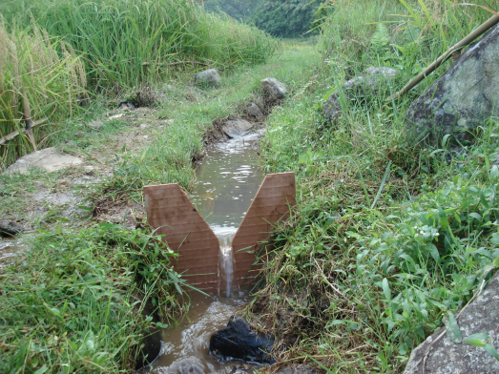

Figure 2: Triangular weir

**Methods**

**Crops water requirement**

Water requirements for growing lowland rice is calculated from the amount of water losses due to evaporation, transpiration, percolation, seepage and retained in the biomass of the rice crops and involved in several chemical, physical and physiological processes. The need for water irrigation is the amount of water should be added to the field to suffice the gap between crop water requirement and rainfall as formulated as follows: (Sembiring, *et al.,* 2011).

IR = E + T + S + D + P – Re

Where:

IR: water irrigation requirement (mm); E: Evaporation (mm); T: Transpiration (mm); S: soil saturation (mm); D: flooding (mm); P: Percolation (mm); Re: Effective rainfall (mm)

Irrigation started from land preparation. controll block (deep flooding) was flooded by a water height of 7 cm. Low level continues flow block was flooded by a water height of 3-5 cm as recomended by crops water balance analysis (Doorenbos and Kassam, 1979). The volume of water used to saturate the soil of the saturated block was estimated. The number of days of non-flooded soil in AWD before irrigation is applied can vary from 1 day to more than 5 days.

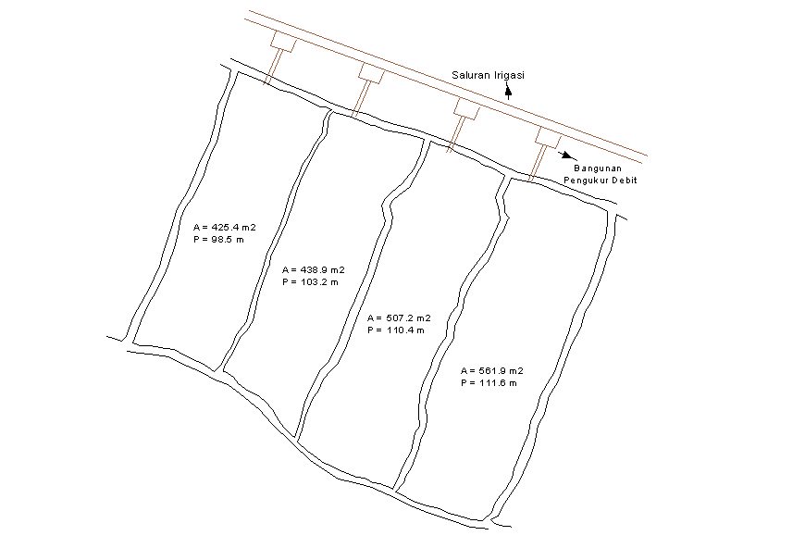

**AWD Irrigation**

**Saturated**

**Irrigation**

**Low Level**

**Cont. Flow**

**Dry**

**Saturated**

**Type and dosage of fertilizer**

Type of fertilizer used is urea, Sp-36 and KCl. Fertilizer dosage follows fertilizer recommendations for rice, i.e : Urea 250 kg/ha, SP-36 100 kg/ha and 100 kg KCl/ha.

**The observed parameters**

*Performance of vegetative development of rice and weed growth*

The vegetative development of rice consisted in observing crop height and the number of tillers. The observations carried out on the7th , 15th, 60th, 75th and 100thdays after planting. The weeds performance was observed at the 45th day after rice planting; it included the type and weight of weeds.

*Performance of rice generative*

The observed parameter during generative growth were flowering period, panicle number , fresh and dry weight of grain, fresh and dry weight of straw, 1000 grain weight and yield.

*Site characteristic*

Soil types were classified as Oxiaquic Eutrudepts. Soil surface was well drainedand very porous ; it indicates a low soil water storage capacity. Typical properties of the Oxiaquic Eutrudepts are for the surface layer olive brown (25Y 4.0/3, silt loam texture andgreyish dark brown (10YR 4.0/2 ) and dark brown (10YR 4.0/3 ) , clay fine sandy gravel for the sub surface layer.

Mean annual rainfall was 2.205 mm versus potensial evapotranspiration about 1.264 mm.The monthly rainfall and evapotranspiration data distributions, shows that the experimental station have water deficit during 5 months from June to October. By comparing daily rainfall and evapotranspiration during the second growth period of rice planting (May–September)it shows a period of water deficit that may last about 70 days mostly on June – August (Figure 3).

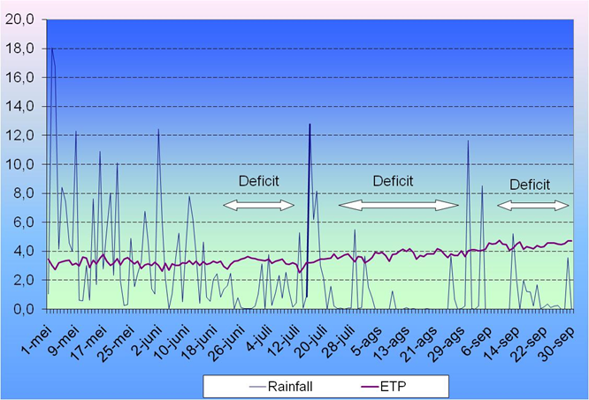

Figure 3. Daily rainfall and evapotranspiration   
 distribution during late season

**RESULTS AND DISCUSSION**

**Water balance for rice**

Water balance simulation for a planting date of rice at the begining of May concluded that its water requirements without flooding during the period of growth were 4,546m3/ha (Figure 4). Regarding the rainfall data the rest of water need must be fulfilled by the water supply from irrigation.

Total volume of water supplied during the rice growing period in the control plot was 2,761.91 m3, distributed during the initial phase for 42 days continuously , about 1,211.56 m3. Water consumption during the vegetative growth phase , flowering and maturation , were 607.95 m3 , m3 759.94 , 182.38 m3 respectivelly. These irrigation method was the most popular irrigation practices applied by local farmer even though during the dry season when the water reserve tend to decrease.

Total water volume related to the low level continous flow irrigation plot was about 1,217.03 distributed into initial phase, vegetative growth phase , flowering and maturation , respectively for 523.24 m3 , 272.07 m3 , 340.10m3 , 81.62 m3.

Water delivered to the alternate wet and dry irrigation plot was about 638.98 m3. The amount of water supply to each successive phase of 270.90 m3 , m3 119.73 , 207.44 m3 and 40.92 m3. Alternate wetting and drying irrigation therefore generates multiple benefits related to reducing water use (adaptation as water is scarce), increasing productivity, and increasing food security (Bouman et al in Siopongco, Joel D.L.C *et al*, 2103)

Total volume supplied for soil saturation plot was

about 549.74 m3. The amount of water supply for each development phase were 183.75 m3, 91.57 m3, 234.64 m3 and 39.78 m3 .

Regardless the performance of rice crop growth, it’s the most efficient treatment in terms of water use. It only required an amount of water around14-20 % of amount of water consumedby the continuous 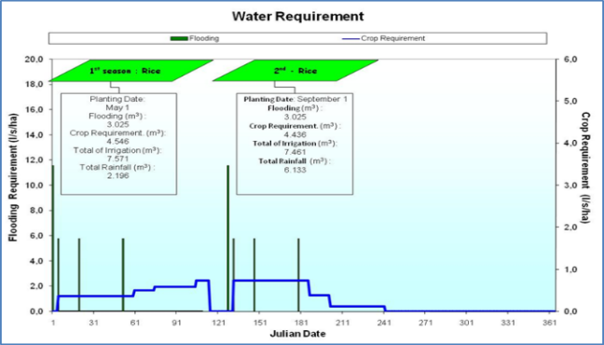deep flooding treatment.

Figure 4. Water balance simulation for rice

**Vegetatif and weeds growth performance**

The vegetative performance of rice plants are reflected in the number of tillers and plant height as well as correlated with yield. The results show that the deep flooding trial have the highest values of plant height and number of tillers, though itdid not show a significant difference with those of the other treatments (Figure 5). Visual field observations and measurements of plant height and number of tillers of rice indicate that the effect of irrigation management on rice growth was not significant. Field observations of the variability weed growth and weed species, which are competitor of rice, showed that the alternate wet and dry irrigation treatment has the greatest diversity of most weed

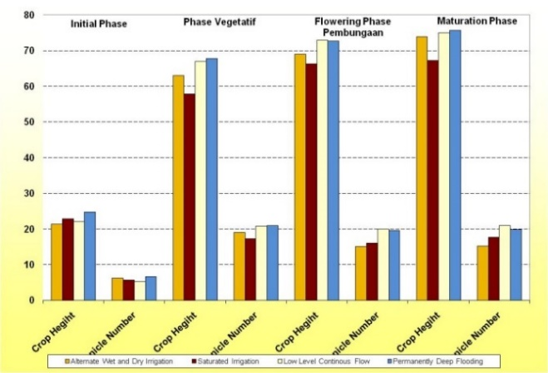 species , and get the highest total volume of the weed wet weight (Table 1).

Figure 5. Performance vegetatif of rice grow

The observation of  [Borrell](http://www.sciencedirect.com/science/article/pii/S0378429097000336)*, et al. (*1997)showed that weed growth was generally higher in unflooded treatments, although weed populations in Saturated Soil Culture or saturated irrigation treatments and traditionally flooded rice were equivalent in the dry season, suggesting that weeds can be controlled in SSC. The *productive* parameters measured were plant panicle length, panicle fill, empty panicles, 1000 grain eight, wet grain weight, dry grain eight, wet straw weight, grain weight, and dry weight harvest as presented in the Table 2.

Panicles length data show that saturated irrigation treatment presents the highest value, on an average 1.02 times higher than the values of the other irrigation treatments. Continous deep flooding produces the highest number of panicles fill around 86.51 %. Refer to the ratio between numbers of the panicle empty and total numbers of panicle, continuous deep flooding irrigation produced highest productivity panicles with empty panicles about 13, 49% comparing with low level continuous flow, saturated and alternate wet and dry irrigation about 20.60%, 23.75% and 20, 27% respectively of the total number of panicles. Regarding 1000 grain weight, the low level continous flow irrigation produced the highest value about 28.17 grams, while alternate wet and dry irrigation, deep flooding and saturated irrigation produced 25.80, 27.03, and 26.53 grams respectively (Figure 6). Research coundected by [Borrell](http://www.sciencedirect.com/science/article/pii/S0378429097000336), *et al*. (1997) showed that there were no differences between SSC (Saturated soil culture) or saturated irrigation and the traditional method of irrigation in any of the grain quality components measured, indicating that this water saving method did not lower grain quality. The rice yield of deep flooding irrigation treatment was equivalent to 5.6 tons/ha of dry paddy while the yields of low level continuous flow irrigation, alternate wet and dry irrigation and soil saturation treatments reached 5,3 tons/ha, 3.36 tons/ha and 2.80 tons/ ha respectively.

Table 1 : Observations of the diversity of weeds and weed fresh weight 35 days after rice planting

|  |  |  |  |
| --- | --- | --- | --- |
| Irrigation Plot | Type of Weeds | | Wet Weight (gram) |
| Local Name | Scientific Name |
| Alternate wett and dry irrigation | Jajagoan  Kakawatan  Mute  Gunda  Samangi  Randa Katisan  Cacabean  Bulu mata munding | Enchnochoa glabrecens  Cynodon dactylon  Cyperus difformis  No name  F. Asteacaea  Marsileaceae  F Onagraceae  Cyperus iria L | 245.3  14.9  1.3  0.7  4.1  23.1  50.7  288.5 |
| Saturated irrigation | Jajagoan  Kakawatan  Cacabean  Bulu mata munding | Enchnochoa glabrecens  Cynodon dactylon  F Onagraceae  Cyperus iria L | 292.9  51.5  149.1  90.1 |
| Low level continuous flow | Jajagoan  Bulu mata munding  Kakawatan  Mute | Enchnochoa glabrecens  Cyperus iria L  Cynodon dactylon  Cyperus difformis | 70.6  4.3  3.2  1.3 |
| Deep flooding irrigation | Jajagoan  Bulu mata munding  Kakawatan  Talog Toya | Enchnochoa glabrecens  Cyperus iria L  Cynodon dactylon  Commellina bunghalensis | 18.5  1.7  1.7  2.4 |

Table 2: Yield performance

|  |  |  |  |  |
| --- | --- | --- | --- | --- |
| Parameters | Irrigation Treatment | | | |
|  | Alternate Wet and Dry saturated | Saturated | Low level  Continous flow | Continous deep flooding |
| Panicles length (cm) | 22.86 | 23.49 | 23.05 | 22.85 |
| Panicles fill (%) | 79.73 | 76.25 | 79.40 | 86.51 |
| Panicles empty (%) | 20.27 | 23.75 | 20.60 | 13.49 |
| 1000 grain weight(g) | 25.80 | 26.53 | 28.17 | 27.03 |
| Wet grain weight(g)/m2 | 47.15 | 45.21 | 63.69 | 59.20 |
| Dry grain weight(g)/m2 | 34.41 | 29.67 | 48.21 | 44.25 |
| Wet straw weight(g)/m2 | 110.12 | 82.60 | 106.50 | 108.46 |
| Wet paddy(kg)/m2 | 0.57 | 0.55 | 0.77 | 0.72 |
| Dried paddy (kg)/m2 | 0.48 | 0.46 | 0.65 | 0.61 |



Figure 6. Thousand grain weight of several   
 irrigation treatment

**Water use efficiency and water productivity**

Water use efficiency is the ratio of grain yield (kg/ha) and the total water consumption of irrigation (m3/ha) without water supply from rain. The experimentation results showed that saturated irrigation produced about 6.32 kg/m3, low level continuous flow irrigation was about 4.35 kg/m3, alternate wet and dry irrigation was about 3.98 kg/m3 and continuous deep flooding was about 2.03 kg/m3/ha of water use efficiency.  [Borrell](http://www.sciencedirect.com/science/article/pii/S0378429097000336) , *et al.* (1997) mention that the trend was for yield to increase with water supply, but there was no significant difference in yield and quality between Saturated Soil Culture (SSC) and traditional flooded production, although SSC used about 32% less water. Therefore the efficiency of water use for grain production (WUEg, g m−2 mm−1) was higher in SSC than in traditional flooded production in the wet season and a similar trend existed in the dry season.

*Water productivity* is expressed by the ratio between the amount of water (kilograms) used to produce an agricultural product and the weight of the product (grams). Therefore, the higher the ratio the more effective in using water. Regardless of the yields obtained, the water productivity of saturated irrigation reached the highest value about 0.9 g/kg, it means that every kilogram of water consumed by rice plants produced 0.9 grams of grain. Alternate wet and dry irrigation and low level continuous flow irrigation water productivity ratio is about 0.66 g/kg and 0.55 g/kg respectivelly. Continues deep flooding water productivity ratio is about 0.26 g/kg (Figure 7)



Figure 7. Water productivity

Bouman, *et al.* (2007 at Setiobudi, 2008) mentioned his observation in Guimba and Munoz of Philipines and Hubei, China that water productivity of alternate wet and dry (AWD) irrigation comparing with deep flooding irrigation was very siginificance results. An AWD irrigation water productivity varies about 0,95 – 1,34 comparing with 0,90- 1,20 of deep flooding water productivity.

**CONCLUSSIONS**

1. The rice yield of deep flooding irrigation treatment was equivalent to 5.6 tons/ha of dry paddy while the yields of low level continuous flow irrigation,alternate wet and dry irrigation and soil saturation treatments reached 5.3 tons/ha, 3.36 tons/ha, and 2.80 tons/ ha respectively.
2. The experimentation results showed that saturated irrigation produced was the most efficience of water use and considerable as an alternative irrigation for upland area with water scarcity problem for rice cultivation
3. Low level continuous flow irrigation was able to save significant water use and produce high rice yield.

**REFERENCES**

Aguilar, M. and F. Borjas. 2005. Water use in three rice flooding management systems under Mediterranean climatic conditions. Spanish Journal of Agricultural Research 3(3): 344-351

[Borrell](http://www.sciencedirect.com/science/article/pii/S0378429097000336) , A., Garside A and Fukai S**.** 1997. Improving efficiency of water use for irrigated rice in a semi-arid tropical environment. [Field Crops Research](http://www.sciencedirect.com/science/journal/03784290).

BB PADI. 2006. Direktori padi Indonesia 2006. Balai Besar Penelitian Tanaman Padi. Badan Penelitian dan Pengembangan Pertanian.

Doorenbos, J., and A. H. Kassam. 1979. Yield Response to Water. FAO Irrigation and Drainage Paper no 33. 193pDoorenbos. J. and A.H. Kassam. 1979. Yield Response to Water. FAO Irrigation and Drainage Paper no 33. 193

Gill, M.S., Kumar Pradeep and Kumar Ashwani. 2006. Growth and yield of direct seeded rice (Oryza sativa) as influenced by seeding technique and seed rate under irrigated conditions. Indian Journal of Agronomy. 51(4):283-287.

Kima, A.S., W. G. Chung, Yu-Min Wang. 2014. Improving Irrigated Lowland Rice Water Use Efficiency under Saturated Soil Culture for Adoption in Tropical Climate Conditions. Water 6: 2830-2846. doi:10.3390/w6092830

Pandian, B.J., Sampathkumar, T., Chandrasekaran, R. 2014. System of Rice Intensification (SRI): Packages of Technologies Sustaining the Production and Increased the Rice Yield in Tamil Nadu, India. Irrigat Drainage Sys Eng 3: 115. doi:10.4172/2168-9768.1000115

Parihar, S.S. 2004. Effect of crop establishment method, tillage, irrigation and nitrogen on production potential of rice (Oryza sativa)-wheat (Triticum aestivum) cropping system. Indian Journal of Agronomy 49(1): 1-5.

Ramakrishna, Y., S. Subedar, Prihar, S.S. 2007. Influence of irrigation regime and nitrogen management on productivity, nitrogen uptake and water use by rice (*Oryza sativa*). Indian J. Agron. 52 (2), 102-106.

Sembiring, H., and Abdul Karim Makarim. 2011. Current status of agricultural water management in Indonesia. Indonesian Center for Food Crops Research and Development.

Setiobudi, D. 2008. Teknologi hemat air dalam budidaya padi sawah di lahan beririgasi. Makalah Seminar Rutin Puslitbangtan. Oktober 2008.

Sheikh Helena Bulbul, Md. R. Rahman. 2014. Sustainable Water Use Efficiency for Rice Cultivation in Rajshahi of Bangladesh.American Journal of Agriculture and Forestry. 2(4): 146-153. doi: 10.11648/j.ajaf.20140204.17

Siopongco,. Joel D.L.C., Reiner Wassmann, B.O. Sander 2013. Alternate wetting and drying in Philippine rice production: Feasibility study for clean development mechanism

Singh, A., N. Aggarwal, G. S. Aulakh, R. K. Hundal. 2012. Ways to Maximize the Water Use Efficiency in Field Crops – A review. Greener Journal of Agricultural Sciences. 2 (4): 108-129.

Sosiawan, H. 2002. Sénsibilité du systéme rizicole irrigué au risque de la diminution de la ressource en eau dans la region de Purwakarta (Ouest Java - Indonesie). ENSA de Montpelier. France. Mémoire du CESA.

Sosiawan, H. and Kasdi Subagyono. 2007. Pembagian air secara proporsional untuk keberlanjutan pemanfaatan air. Jurnal Sumberdaya Lahan. BBSDLP

Wang, F.H., X. Q. Wang, K. Sayre. 2004. Conventional, flood irrigated, flat planting with furrow irrigated, raised bed planting for winter wheat in China. Field Crop Res. 87: 35-42.

Sheikh Helena Bulbul, Md. Redwanur Rahman. 2014. Sustainable Water Use Efficiency for Rice Cultivation in Rajshahi of Bangladesh.American Journal of Agriculture and Forestry. 2(4): 146-153. doi: 10.11648/j.ajaf.20140204.17

Xu J, Peng S, Yang S, and Wang W, 2012. Ammonia volatilization Losses from a rice paddy with different irrigation and nitrogen managements. *Agricultural Water Management*, 104, pp.184–192. Available at: http://linkinghub.elsevier.com/retrieve/pii/S0378377411003374 [Accessed March 13, 2013].