AMONIUM AND NITRATE OF SOIL IN RELATION TO WATER TABLE FLUCTUATION AT THE TIDAL RICE FIELDS
Warsito¹⁾, Susanto, R.H.²⁾, Saleh, E.³⁾ and Novia⁴⁾

Abstract

The reclaimed lowlands of Indonesia with the respective of 256 hectares of secondary block consist of 16 hectares of tertiary blocks, were used for rice plant production. Paddy was planted during the rainy season of November to February. It was followed by water melon plant in March to May. Then corn was growed in the dry season of June to September finally. Fluctuations of water table in the farm is very crucial in determining the cropping calender. Water management with free drainage approach is influenced by tidal water movement into the tertiary canals bordering the farmers fields. A constant water retention -10 cm below the canal bank has increased the water table in the farm from -10 cm to +20 cm. Water retention (controlled drainage) mode was applied by the farmers especially during the rice growing period. The release of water in the canal to a depth of -50 cm below the canal bank had lowered the water table level to -20 cm. During almost 200 days of experimental work, soil and water samples were taken by 11 times. The content of NO₃⁻, NH₄⁺and pH of the soil sample and be analyzed in relation to the water table fluctuation. Groundwater level does not show the effect on nitrate release on the urea application stocked. however, on the high ground water level it appears to be more in control of ammonium release compared to the ground water level of -20 cm

Key words: amonium, nitrate, water table fluctuation, lowland

- Graduate Student of Sriwijaya University
2,3,4) Sriwijaya University Lecturers; Corresponding author: mazwar_unsri@yahoo.com

1.Introduction
Development of tidal lowland in South Sumatra has been conducted by government since 1969 through transmigration program. The utilizedand improved tidal lowland land of South Sumatra covered approximately 2.92 millions ha (Euroconsult, 1995). It was reported that 60 percent of rice production in South Sumatra with magnitude of 2.8 million tons is currently produced from lowland areas(Food Crop and Horticulture Council of South Sumatra, 2015). The reclaimed lowland is frequently experiencing lack of fresh water supply due to low tidal irrigation that is incapable reaching into the land and low rainfall. Moreover, porous soil condition results in high value of soil hydraulics conductivity caused very high water losses of water due to percolation and lateral seepage. It is caused by the difficulty to retain the rainfall water. This made a sharp drawdown of the shallow water table in the farm (Susanto, 2007). The water table depth, especially in dry season, is lower than the depth of pyrite layer depth which results in oxidation process.
Water management is one of the important factor for land management at reclaimed tidal lowland area (Suprianto et al., 2009). This management is not only reduce or add surface water availability, but also reduce acidity, minimize land acidity due to phyrite layer oxidation, to minimize salinity hazards and flooding risks, as well as reduce toxic chemical compounds as a result of phyrite layer oxidation (Imanuddin and Susanto 2005). In order to establish the above conditions, water management operation is geared toward aspects of water table management that is always located above phyrite layer and land leaching through a controlled drainage systems (Skaggs, 1991).
The pattern of cultivation of agricultural crops in tidal wetlands is also marked by the intensive use of large amounts of agrochemicals which include fertilizers, pesticides and herbicides. Among the three production facilities the use of nitrogen inorganic fertilizers is greater, and tends to increase.
A common problem encountered in agricultural land in the wet tropics is the low balance between the amount and time of nutrient availability and the amount and time needed by plants (Van Noordwijk and De Willigen, 1987). This imbalance causes N leachate to the layer below the reach of the root of the plant so that it causes NO₃⁻ pollution in groundwater and waters (Brady & Weil, 2002). While it is known that the efficiency of nitrogen fertilization for plants is low, so there is a possibility of releasing some nitrogen into the waters
In term of the above potential and constraint, tidal lowland development needs a proper planning, management, and utilization of land as well as proper technology application, especially water management aspect (Susanto, 2003). This soil has a good potential for agricultural development through proper management. Proper planning of water management is certainly need data of daily soil water status so that yearly monitoring of that data is essential. Water table dynamics within the crop root zone has highly significant effect on water availability for crops. Therefore, a field study to monitor water status at tertiary blocks is needed in order to develop water management and land utilization planning. Therefore, the study objective is to investigate water table dynamics within tertiary blocks in order to determine correlation between water level in the canal and within the soil at the farmers field during drainage. Daily water level fluctuation in the canal and water table fluctuation within the soil are observed. Also measured measurements of ammonium and nitrate during the rice plant growth phase after application of urea fertilization

2.Materials and Methods

Study and field investigation have been conducted at tidal lowland reclamation area. The demonstration plots (demplot) of 16 ha is located at Primer 17-6S, Banyu Urip, Tanjung Lago, Banyuasin District (Fig. 1). Study and field monitoring are conducted within two growing seasons consisting of wet and dry seasons. Observation period (water table monitoring) in the field is carried out from January to June 2016. Soil samples were taken and analyzed 11 times during this periods. The kind of analysis are N-amonium and N-nitrate, The sample is taken once a week since the application of nitrogen fertilizer.

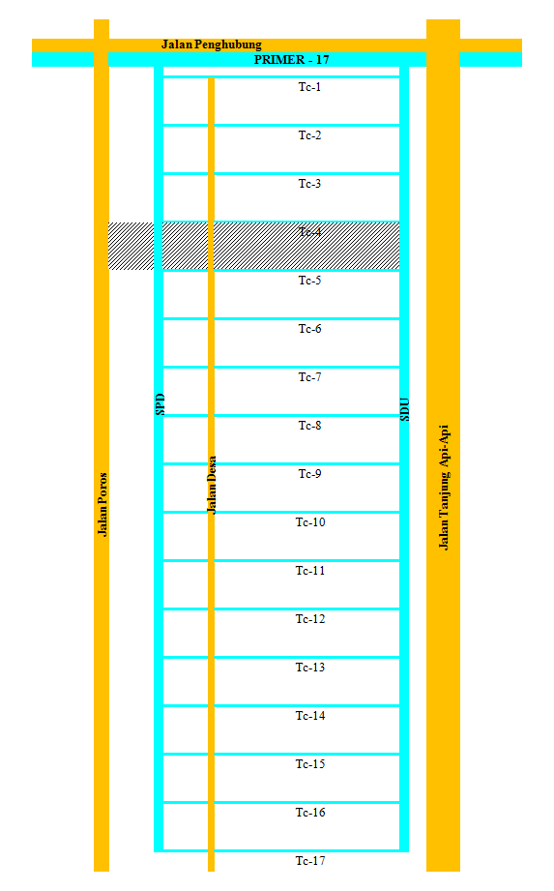
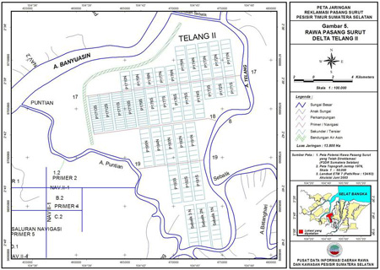
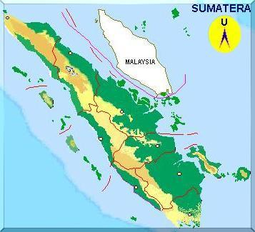

Study Site

Figure 1.The demonstration plots (demplot) of 16 ha is located at Primer 17-6S, Banyu Urip, Tanjung Lago, Banyuasin District.

The water table fluctuation measurement at farmers field was conducted by using observation wells made from perporated PVC pipes. Observation wells are placed midway between tertiary canals spacing of 200 m. The distance of the wells are 100 m, 50 m, 25 m, 12.5 m and 2.0 m from the tertiary canal. Water table fluctuations were daily observed as well as the water level at the tertiary canals. In addition, daily rainfall was observed by direct measurement from rainfall tipping buckets for every 7:00 a.m. Soil sampling is carried out to determine the physical properties of the soil such as texture, bulk density, total pores volume, soil hydraulics conductivity, and acid sulphate layer depth. Potential of tidal water penetration within the canals and water table fluctuations at tertiary block were daily observed during two growing seasons (wet and dry seasons). Results of the field observation data were analyzed and compared with observation of the critical value of soil water depth that is needed to grow the crops. The cropping pattern for this area is rice, ratton rice or water melon, and corn.
3.Results and Discussion
3.1.General Condition of the Study Site in Tanjung Lago, Banyuasin, South Sumatra
The reclaimed lowland was classified into agroclimate type of C1, based on Oldeman classification with monthly average temperature of 32⁰C and yearly average rainfall of 2500 to 2800 mm. Rainy season was occured from November to April, whereas the dry season was occured from March to October (Fig. 2). It is shown from figure that the rainfall was relatively low and ineffective to fulfill the crop water requirement at the dry season. This fresh water deficit problem was combined with the inflow of seawater or salt water during high tide. Based on a high tide water that overflow into the land, Tanjung Lago lowland area in general wasclassified into B/C type overflow which it is not flooded during high tide or low tide. The land was not overflow by tide water, but the tide water penetrated into the primary, secondary and tertiary canals which affected the water table fluctuation in the farm. The available water was mostly from rainfall water. Since tide water did not flow into the land which results in rain-fed characteristics of the land. Quality of this land was characterized by unripe physical soil characteristics, high total pores volume (60 to 70%), low bulk density (0.90 to 1.0 g/cm³), light texture at the upper layer of 0 to 30 cm, and medium texture at the depth of 30 to 60 cm. Soil hydraulics conductivity was about 9 to 12 cm/h. This condition created the high water losses at this area. Due to low intensity of soil tillage, hardpan layer was not developed in this land (Warsito et al., 2017)

Figure 2.Rainfall was occurred from January to December 2016.

3.1.Water Level Fluctuation at Tertiary canal TC4 upstream of the tertiary gate
Observed water level downstream of the tertiary gate TC4 showed the effect of tidal water movement. The water level fluctuates according to the tidal water conditions. The water level downstream of the TC4 gates are always below the soil surface. It has several water level of peaks which varies during the rice growing season starting from December up to April (Fig. 3).
Jan
Feb
Mar
Apr
Mei
Jun

Figure 3. Water Level Fluctuation at Tertiary canal TC4 upstream of the tertiary gate.

Results of observation showed that yearly rainfall is 2500-2800 mm/yr. This rainfall magnitude is actually sufficient to support rice water requirement. The effective rainfall is not optimal due to porous soil and high hydraulics conductivity as well as insufficient water management facilities. This condition is exaggerated by insufficient tidal water penetration. Free drainage mode applied by the farmers has to be changed to controlled drainage mode in this case as shown in Figure 4.
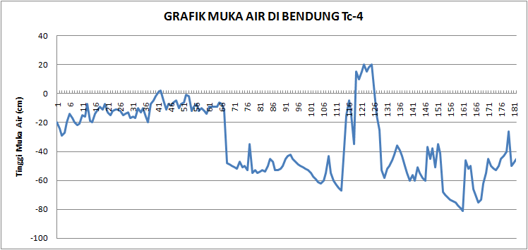
Jan
Feb
Mar
Apr
May
Jun

Figure 4. Changing of Free drainage mode applied by the farmers to control drainage mode.

As shown in Figure 4, water was retained within the tertiary canal TC4 in January to February at level of 10 to 20 cm below the soil surface. This effort is to make fully rainfall water retention in the paddy field during the vegetative growth of rice planted at the end of December 2015. Lateral seepage from the land into the tertiary canals as well as surface runoff will be reduced with a high water level position within the tertiary canals bordering the farm. Rainfall in January and February were stored effectively with water retention at the TC4. The water at canal TC4 was released to average of -50 cm during March and May to create dry farm land for rice harvest. The reducing of the water level at TC4 decreased the water level in the farm. Another water retention was occurred at the end of April. This is due to the land preparation for corn growing season. Free drainage mode was applied at TC4 during May to June onward for the corn growing season.

3.3.The Effect of TC4 water retention on Water table fluctuation within the soil at the observation Well 1 (near the tertiary canal TC4)
Results of daily water table analysis near the tertiary canal were shown in figure 5. Water table fluctuation within the soil near the canal TC-4 had similar trend to the fluctuating water level inside the TC-4. After the water was retained inside the TC-4 (In January and February), the water table at well 1 started to increase from less than 10 cm below the surface upto 3 to 7 cm above the soil in January and to about 10 cm above the soil in February and the mid of March. The increase of water table on the land with water retention in the TC4 follow the rainfall pattern during the same period. Lowering water level inside TC4 to -50 cm (Fig. 4) has lowered the water level in the farm to -20 cm (Fig. 5).

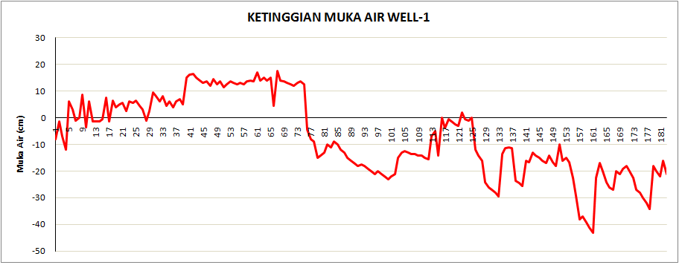
Jan
Feb
Mar
Apr
May
Jun

Figure 5.The Effect of TC4 water retention on Water table fluctuation within the soil at the observation Well 1 (near the tertiary canal TC4).
Water table in Well 1 started to decrease with the release of water in the canal TC4 following the less rainfall in April. This water table fluctuation with free drainage was applied following the rainfall in May onward.
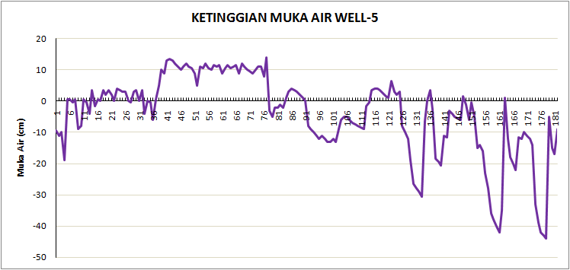
Jan
Feb
Mar
Apr
Mei
Jun

Figure 6.
Slightly different respond was observed at Well 5 about 100 m from the tertiary canal. Water table in January and February was close to the soil surface while at Well 1 near the tertiary ofabout 10 cm above the ground. Water table near the filled tertiary canal rised quickly than that of the area away from the tertiary canal. During March until mid of April, the level of water table in near site (Well 1) and far site (Well 5) from the canal TC4 are almost the same as the magnitude of 10 cm above the ground. It is clearly showed that water retention in the bordering tertiary canal with the existing rainfall will help to retain water in the farmers fields. Paddy growing season in staring end of December 2015 until April 2016 will really need water retention in the tertiary to make the rainfall effective to support high water table at the farmers field.
Land and water management systems is a key factor for the succeed of food crops development at tidal lowland area. Agrophysical of land variations result in diversity of management systems within an area that need different approaches. Water management in tidal lowland was absolutely different than that of irrigated lands. Soil physical conditions, rainfall pattern, and tidal water effects were predominant factors in planning of the on farm water management. Some of important soil physical characteristics are total pores volume, texture, and soil hydraulic conductivity. Pore volume of soil layer within crop root zone is vary in term of their forms, numbers, and sizes. The water availability within these pores are affected by soil, climate, crops, as well as land or water management practices.
Water management approach at the on farm level (free drainage, controlled drainage or water retention, and subirrigation) was applied differently depending on the water regime needs attheon farm level. Cropping pattern of crops planted at the farmers field certainly related to the water table fluctuation. It is clearly showed that rice is best growing when the water table was located near the soil surface. Corn was certainly need a lower water table for the development of deeper root zone.

4. Nitrate and Amonium of the soil
4.1. N-Nitrate
During almost 200 days experimental study, soil and water samples were taken 11 times and analyzed in relation to the water table fluctuation. The content of NO₃⁻, NH₄⁺, pH of the water sample were related to the observed water table fluctuation.
The results of nitrate analysis is as shown in the Figur 7. Figure 7 shows that measurement of nitrate the first week after application of urea showed the lowest value (0.18 - 1.33 mg kg⁻¹). Then nitrate will increase with the range of 2.7-4.05 mg.kg⁻¹ on the condition of the ground water level is stable around +20 cm, its happened during February.
The second urea application is carried out in early March with the ground water level decreasing to -20 cm. There is the same pattern at first the nitrate is low then increases until the last observation is close to 4 mg.kg^{-1.} with the spread of urea application the water level of +20 cm and -20 cm does not show a different effect on nitrate release.

Figur 7. Soil nitrate and water table

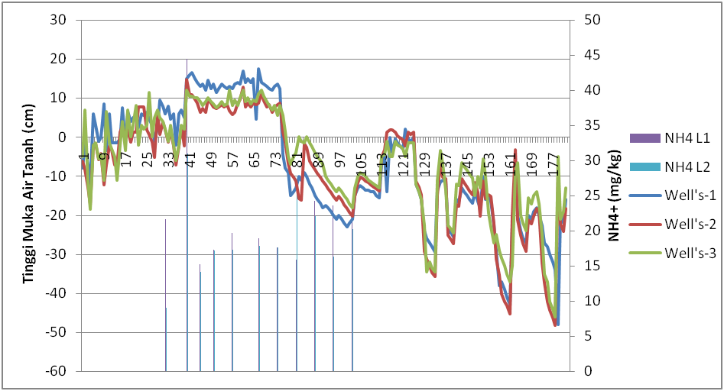
Jan
Feb
Mar
Apr
Mei
Jun

Figure 8. Soil N-Ammonium and water table

4.2. N-Ammonium
Figure 8 shows that the ammonium content in the first week was low, which is about 22.5 mg.kg⁻¹ then increased in subsequent observations to near 45 mg, kg⁻¹. During the ground water level of +20 cm ammonium released in the soil is between 15.27 to 17.50 mg.kg-1. then along with the decrease in ground water level to -20 cm ammonium increases again with a range of 15.8 to 24.2 mg.kg-1

5. Conclusions
Characteristic of porous soil at the study site create relatively high water losses. Therefore, the main objective of water management for paddy field at this area was to hold rainfall water as much as possible. On the other hand, water should be released from the root zones during the corn growing season.A constant water retention -10 cm below the canal bank,in February and March 2016, increased the water table in the farm from -10 cm in January 2016 to +20 cm at the end of February and the beginning of March 2016.Water retention (controlled drainage) mode was applied by the farmers especially during the rice growing period which need a high water table condition. The release of water in the canal to a depth of -50 cm below the canal bank reduced the ground water level in the farmers field to -20 cm.
Groundwater level does not show the effect on nitrate release on the urea application stocked. however, on the high ground water level it appears to be more in control of ammonium release compared to the ground water level of -20 cm

Acknowledgements
Authors would like to express our gratitudes to all parties especially to Faculty of Agriculture, Sriwijaya University;Lowland-Wetland-Coastal Area Data and Information Center that had already provided the facilities for this research and study.

References
Euroconsult. 1995. Monitoring Report of Macro Hydrological Aspects; Agricultural Development Project of Telang and Saleh Areas. Drainage Development Components. Integrated Irrigation Sector Project (IISP).

Food Crop and Horticulture Council of South Sumatra Province. 2015.The Yearly Report of Food Crop and Horticulture Activities. Palembang.

Imanuddin, M.S. and Susanto, R.H. 2005. Water Management in Tidal Lowland Reclamation Areas (a case study of Telang and Saleh Deltaic Areas, South Sumatra). Paper Presented at ICID Congress in Jakarta, 29-30 November 2005.
Skaggs, R.W. 1991. Drainage (in Hanks, J and J.T. Ritchie, 1991).Modelling Plant and Soil System. ASA, CSSA, SSSA. Madison, Wisconsin.

Suprianto, H., Ravaie, E., S.G. Irianto, Susanto, R.H., Schultz, B., Suryadi F.X. and Eelaart, A.V. 2009. Land and Water Management of Tidal Lowlands: Experiences in Telang and Saleh, South Sumatra (Irrigation and Drainage Journal 2009–on line, Wiley Inter-Science (www.interscience .wiley.com).
Susanto, R.H. 2003. Agricultural Drainage Towards an Interdisciplinary and Integrated Approach: A Case of South Sumatra, Indonesia (Paper presented at International Seminar and Exhibition on Prospective of Lowland Development In Indonesia, Palembang, 8-9 December 2003) ISBN: 979-97066-1-0.
Susanto, R.H., 2007. Water Table Fluctuation Under Various Hydro-topographical Condition for Determining the Cropping Calendar (Accredited Journal of Environment and Natural Resources Management. Vol. 6, No.2, June 2007, ISSN .1693 – 0391).
Warsito, Susanto, R.H., Saleh, E. and Novia. 2017. The Effect of Canal Water Retention on the Water Table Fluctuation At the Reclimed Lowlands. Paper Presented at ICID Congress in Iran

